# Higher-Level Review

Decision Reviews (Form 20-0996)

Table of Contents

Higher-Level Review Request Overview 2

User Access 2

Who can access this request? 2

Navigation 3

Higher-Level Reviews 5

Eligibility Subtask 6

Starting the form 9

What if a user is not logged in? 9

What would prevent them from starting the form? 9

Higher-Level Review Request 11

Personal information 11

Housing situation 12

Contact information 13

Issues for review 20

Areas of disagreement 25

Authorization to move to the current decision review process 27

Issue summary 28

Option to request an informal conference 29

Scheduling your informal conference 31

Best time for us to call you 33

Your representative’s contact information 35

Best time for us to call your accredited representative 37

Review application 39

State changes 39

Submission confirmation 53

## 

## Higher-Level Review Request Overview

If a Veteran or their representative disagrees with the VA’s decision, they can request to have a senior reviewer take a new look at their case. The reviewer will determine whether the decision can be changed based on a difference of opinion or an error.

Veterans or their representatives are able to submit a Higher-Level Review paper form. This guide is for the Higher-Level Review online form which was launched in December 2021 and updated in September 2024.

## User Access

### Who can access this request?

Users can access information about the request and without signing in, but they will need to sign in to start the request. The application will be prefilled with their information and the user will be able to save their application in progress.

## Navigation

**Direct url:** <https://www.va.gov/decision-reviews/higher-level-review/request-higher-level-review-form-20-0996/>

**OR** Users are able to access this request via the decision review directory on VA.gov:

Home page > Request a decision review or appeal > Higher Level Review

Dropdown menu



Decision Reviews hub page:



## 

## Higher-Level Reviews

<https://www.va.gov/decision-reviews/higher-level-review/>

On the Higher-Level Review landing page, they are presented with an action link to start the form online:



After navigating to the form introduction page, they will likely be immediately routed to a page that determines their eligibility for an HLR by asking a few short questions. We call this tool a subtask (previously called a wizard)

### 

### Eligibility Subtask

When entering the subtask, the user will be prompted to answer a question that will determine if they are able to submit an online form for their request type. This is what the user will see when encountering the subtask tool

Currently, we only accept disability compensation requests as part of the online form. In the future we may expand to accept other request types.

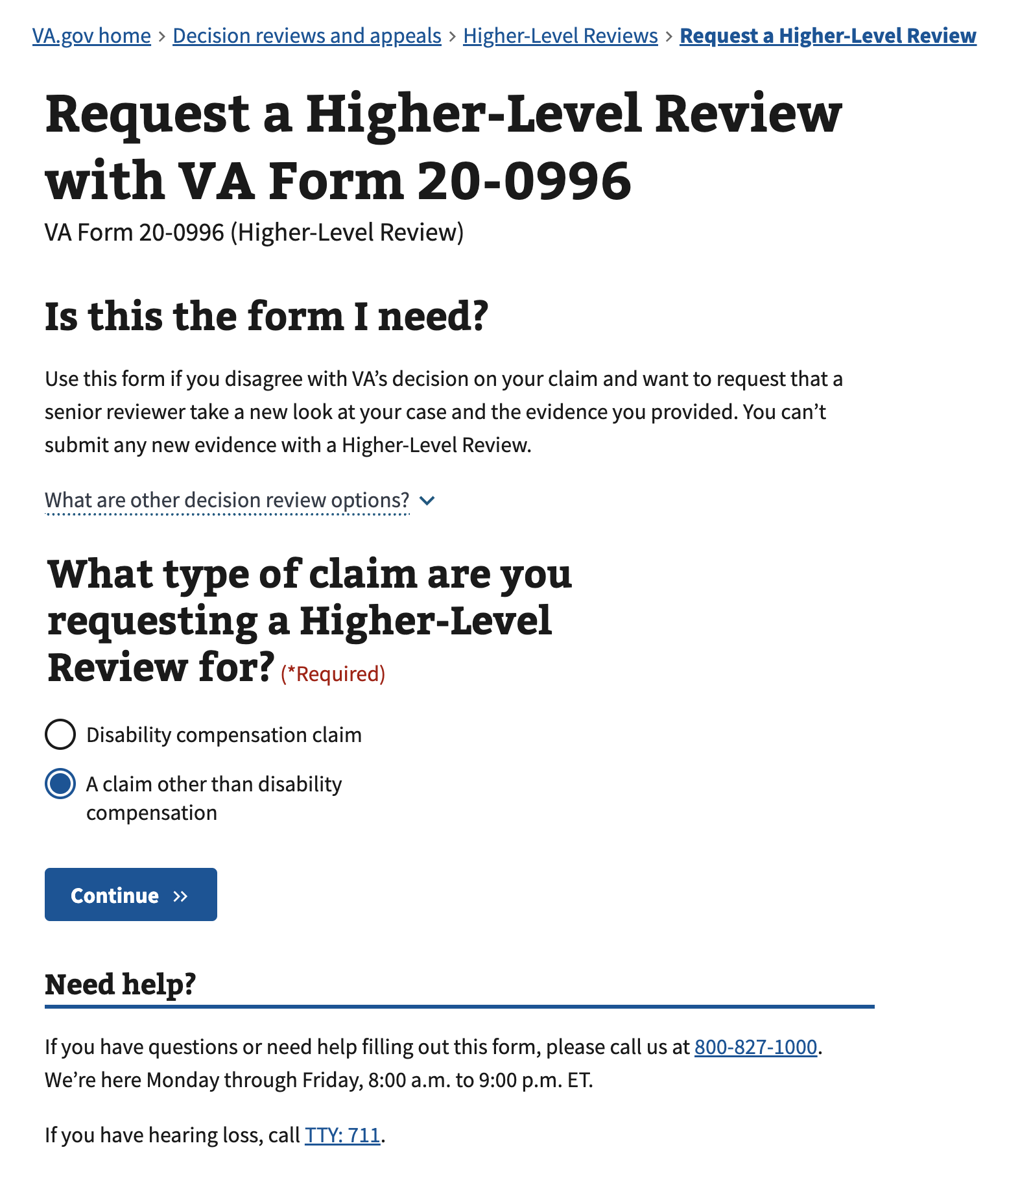

If a user is trying to apply for “A claim other than disability compensation”, and then clicks the continue button, they will see the following message, which directs them to download the PDF.

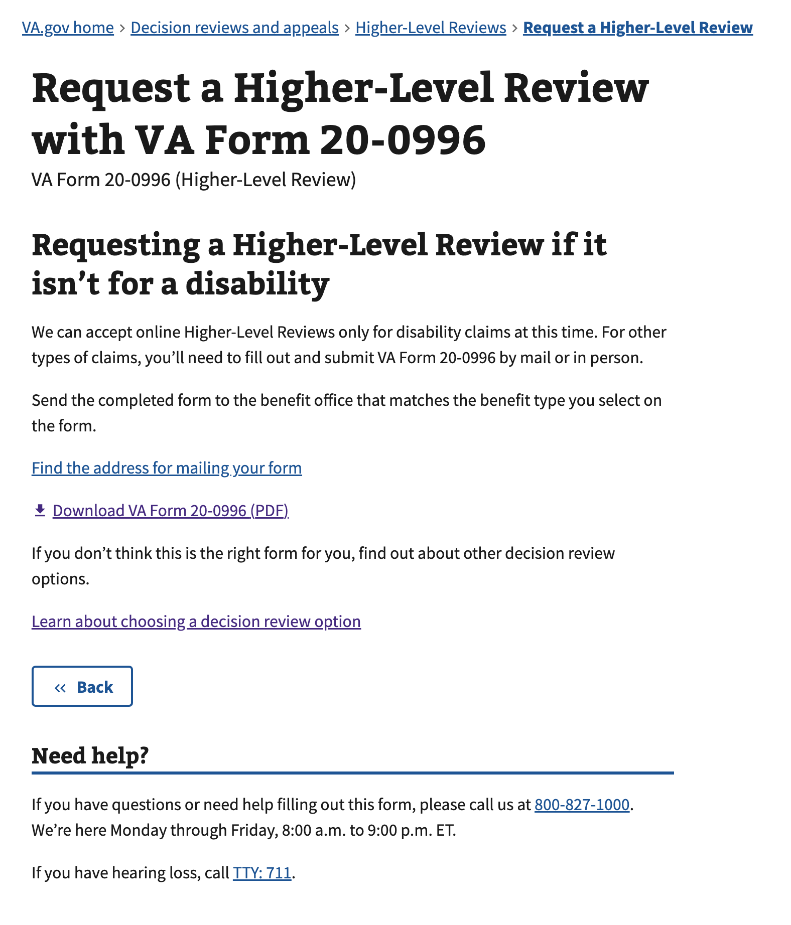

Otherwise, if they select “Disability compensation claim” and choose to continue, they are directed to the [introduction page for the form](https://va.gov/decision-reviews/higher-level-review/request-higher-level-review-form-20-0996/introduction).

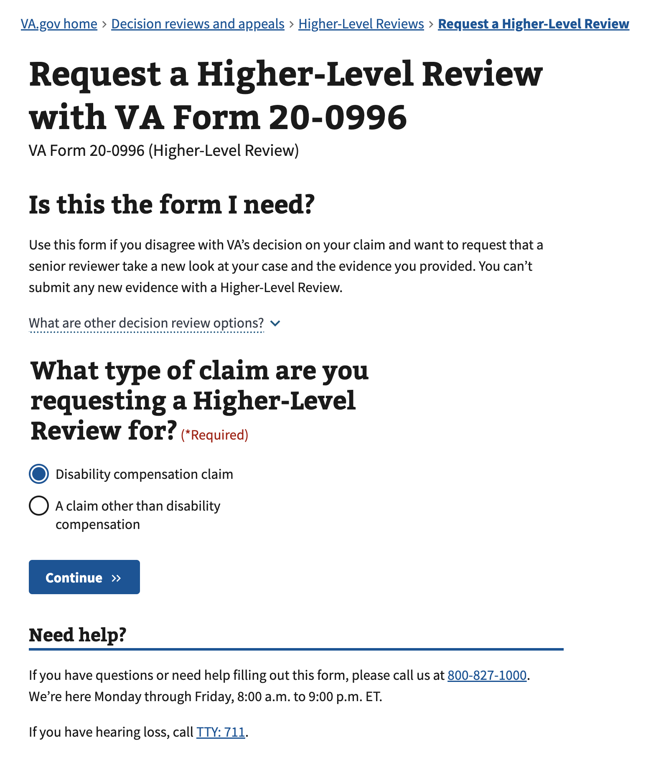

## 

## Starting the form

The user must be logged in to start the form.

### What if a user is not logged in?

In order to access the online form, a user must be signed into their account. If they reach this page and are not signed in, they will be given the opportunity to sign in via a call-to-action button near the bottom of the introduction page.

After signing in, the user will be redirected back to the introduction page and they can continue on the process outlined below.

### Screenshot 2024-07-30 at 10.44.52 AM.png

### What would prevent them from starting the form?

If the user is not Level of Assurance (LOA) 3 verified, they will be prompted to verify their account. Activating the action link will start the user in the process of verifying their account

If VA does not have the user’s last name, Social Security number, or date of birth, an error alert will display which data is missing and prompt the user to call VA

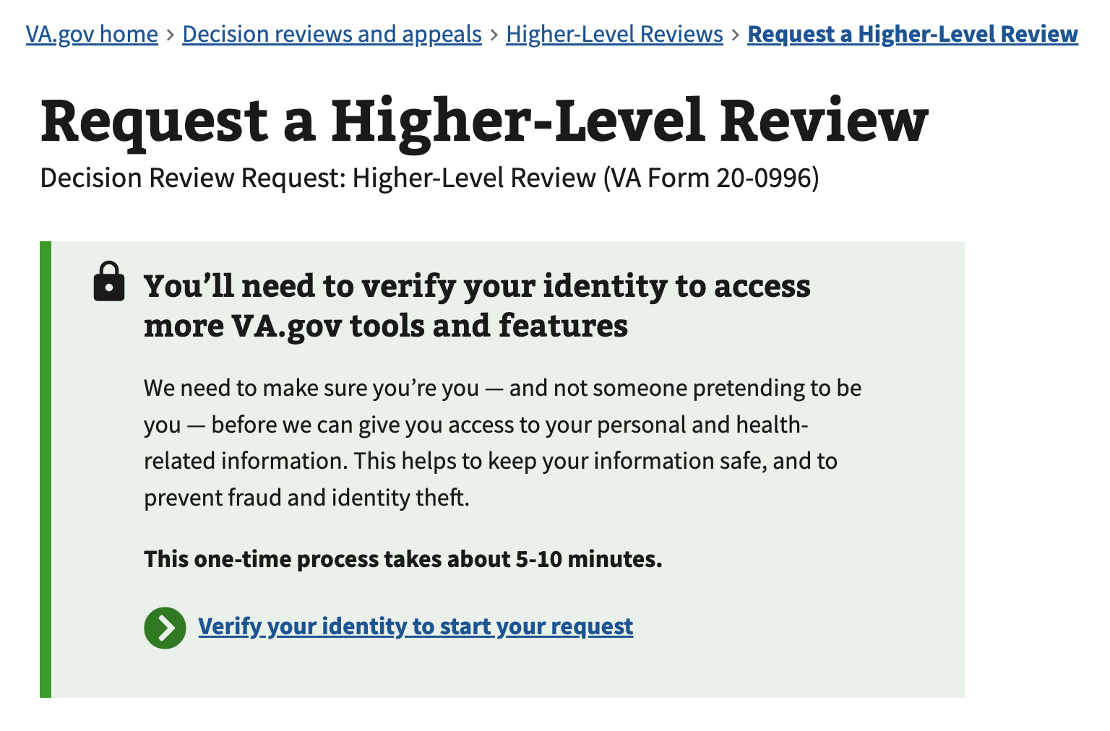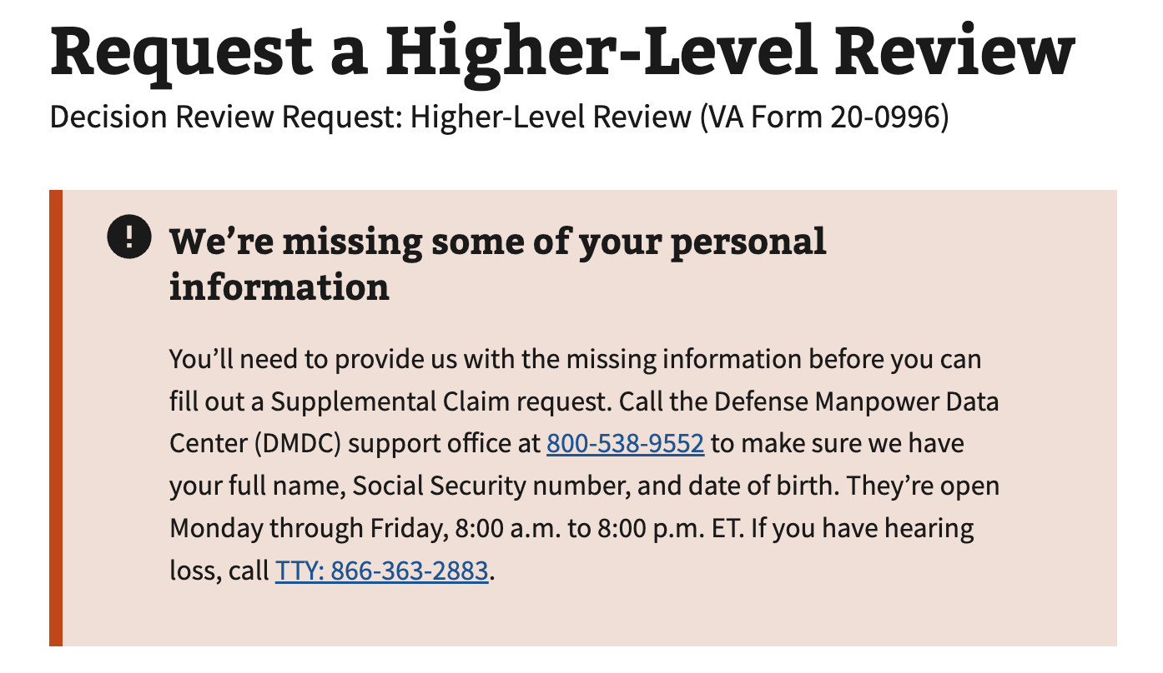

## 

## Higher-Level Review Request

### Personal information

Once inside the form, the first page the user will encounter is a section to confirm or update their personal information. The only form actions a user can take on this page are to either go back or continue. If they need to update their personal information, they will need to do it manually.

### 

### Housing situation

This page asks the user their housing situation. It also explains why VA is asking this question. In the page below, the user has ‘yes’ or ‘no’ options in response:

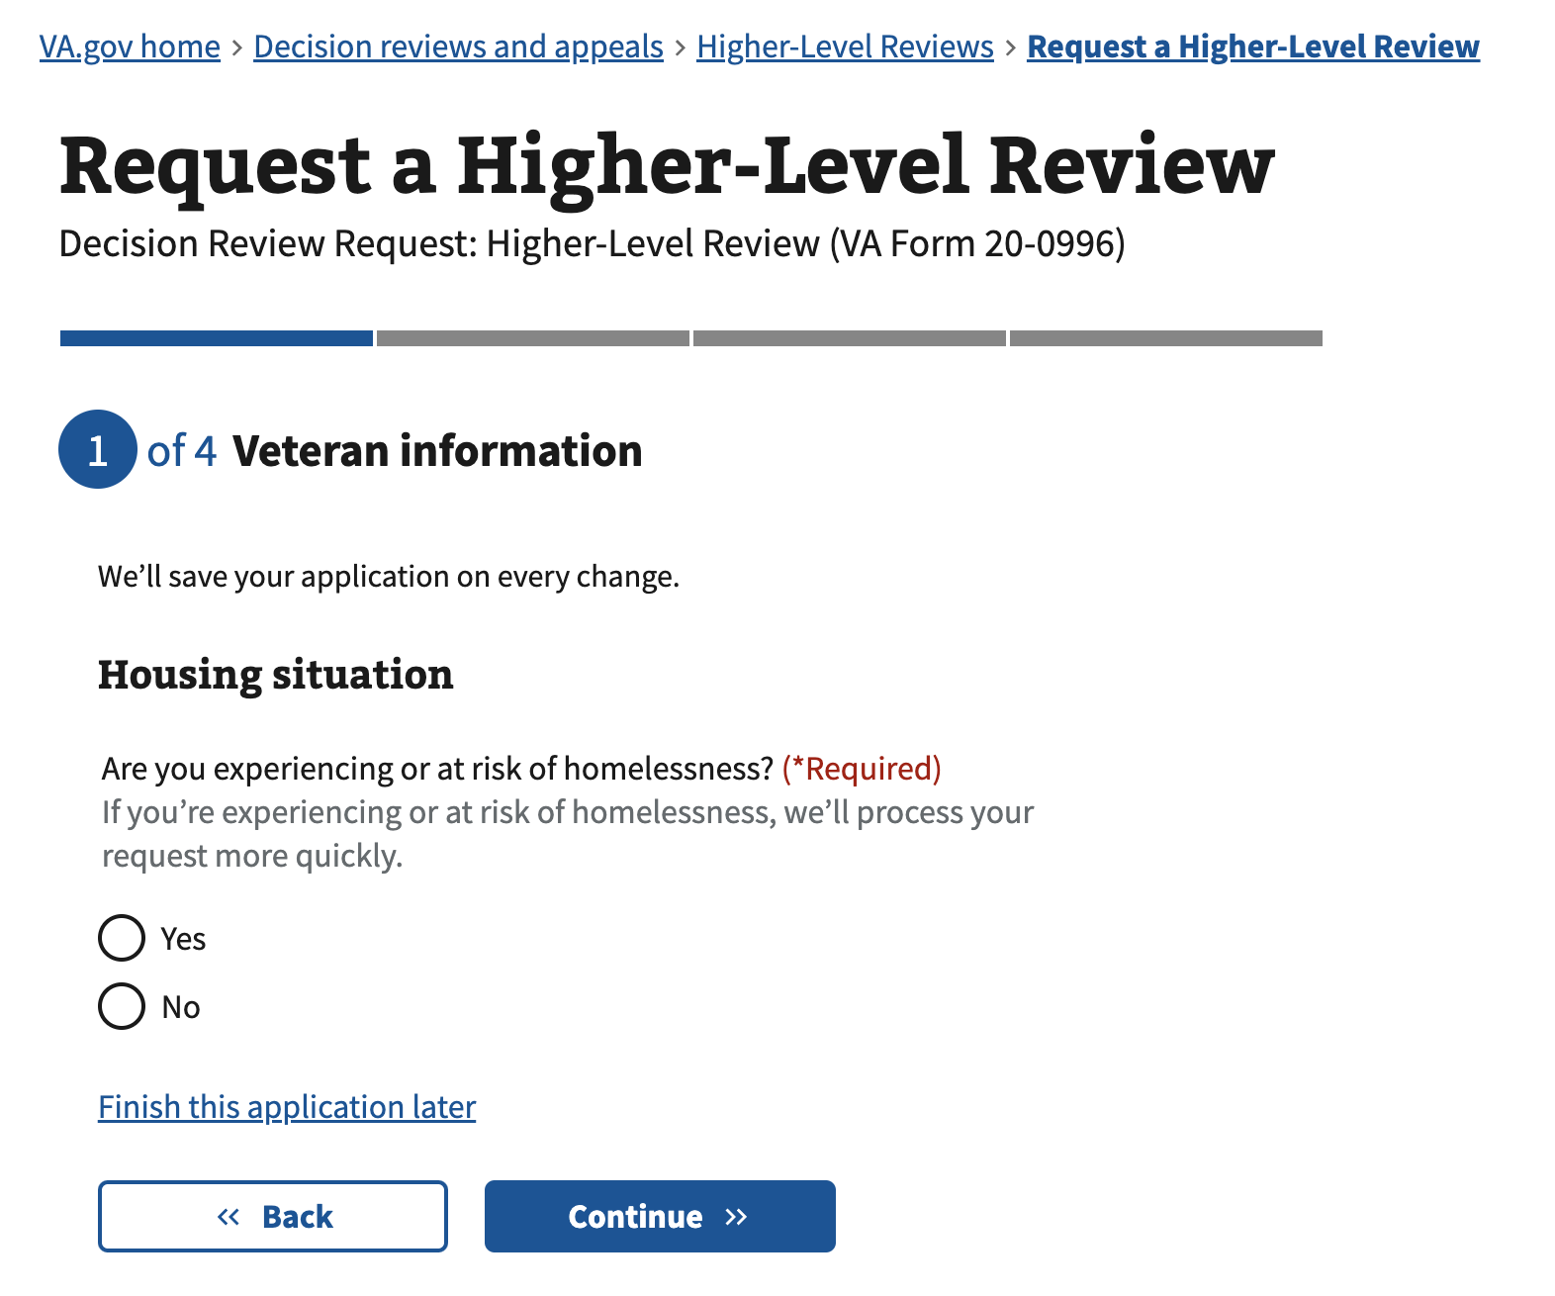

| Field | Required |
| --- | --- |
| Yes | Yes – one selection required |
| No | Yes – one selection required |

If ‘yes’ is selected, the user’s address on the next page will not be required

### 

### Contact information

The next page within the form will be for the user to confirm and/or edit their contact information.

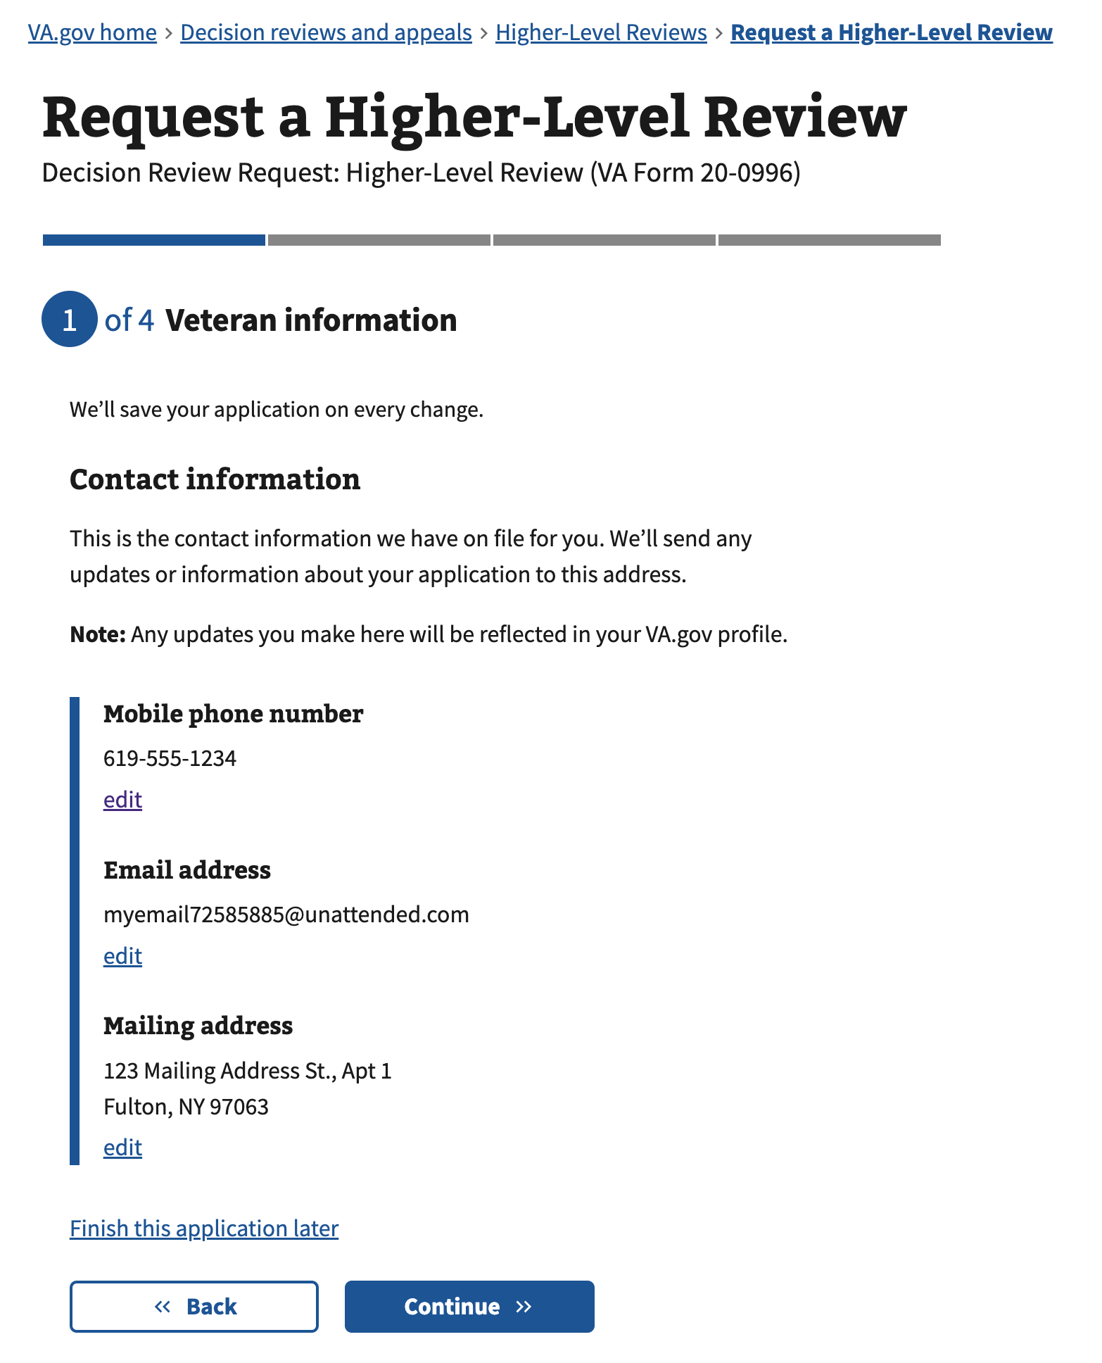

The user can review the contact information prefilled from their profile. Editing the information here will also update their profile information directly.

#### Edit email address

The field will be prefilled with any email address that already exists within the user’s profile.

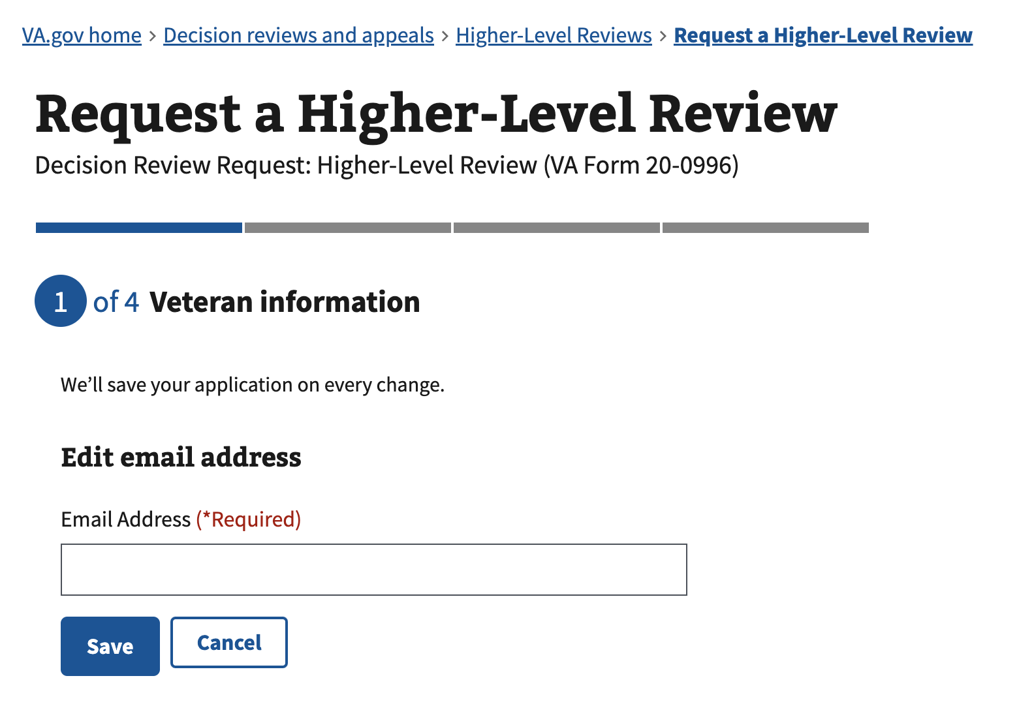

The field is as follows:

| Field | Required |
| --- | --- |
| Email Address | Yes |

Selecting the “Save” button will update their email address within their profile, then return them to the contact information summary page.

Selecting the “Cancel” button will ignore any changes made to the input and not update their profile, then return them to the contact information summary page.

#### Edit mobile phone number

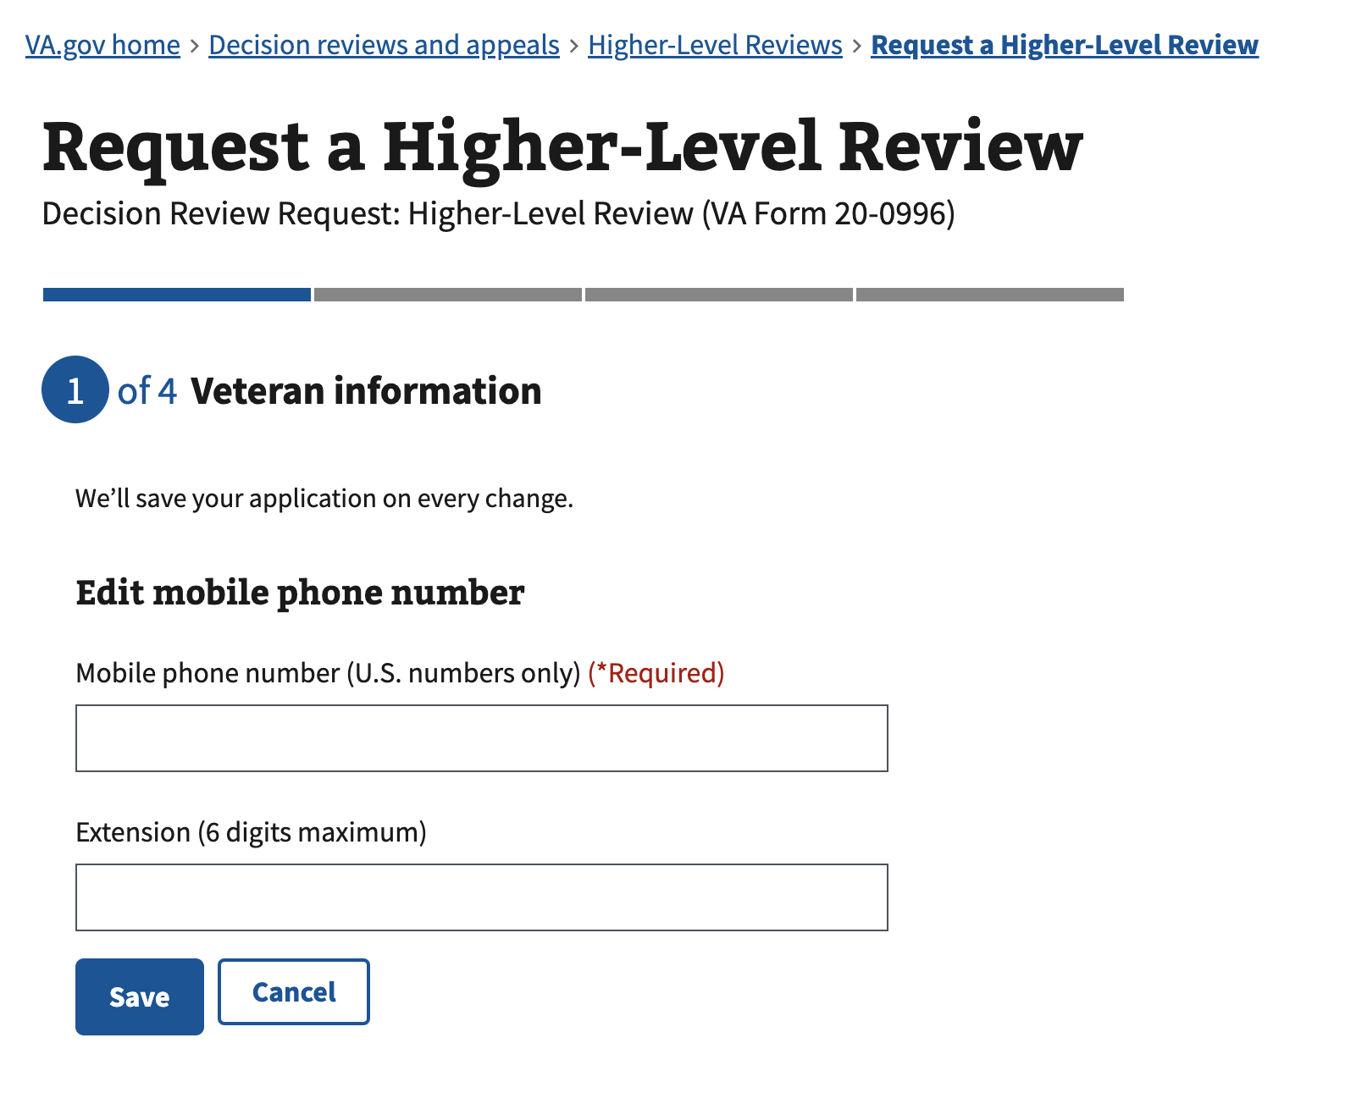

The fields are as follows:

| Field | Required |
| --- | --- |
| Mobile phone number (U.S. numbers only) | Yes |
| Extension (6 digits maximum) | No |

The field will be prefilled with the mobile phone number that already exists within the user’s profile.

Selecting the “Save” button will update their mobile phone number within their profile, then return them to the contact information summary page.

Selecting the “Cancel” button will ignore any changes made to the input and not update their profile, then return them to the contact information summary page.

#### Edit mailing address

##### State changes

###### State 1 – Unchecked I live on a United States military base checkbox

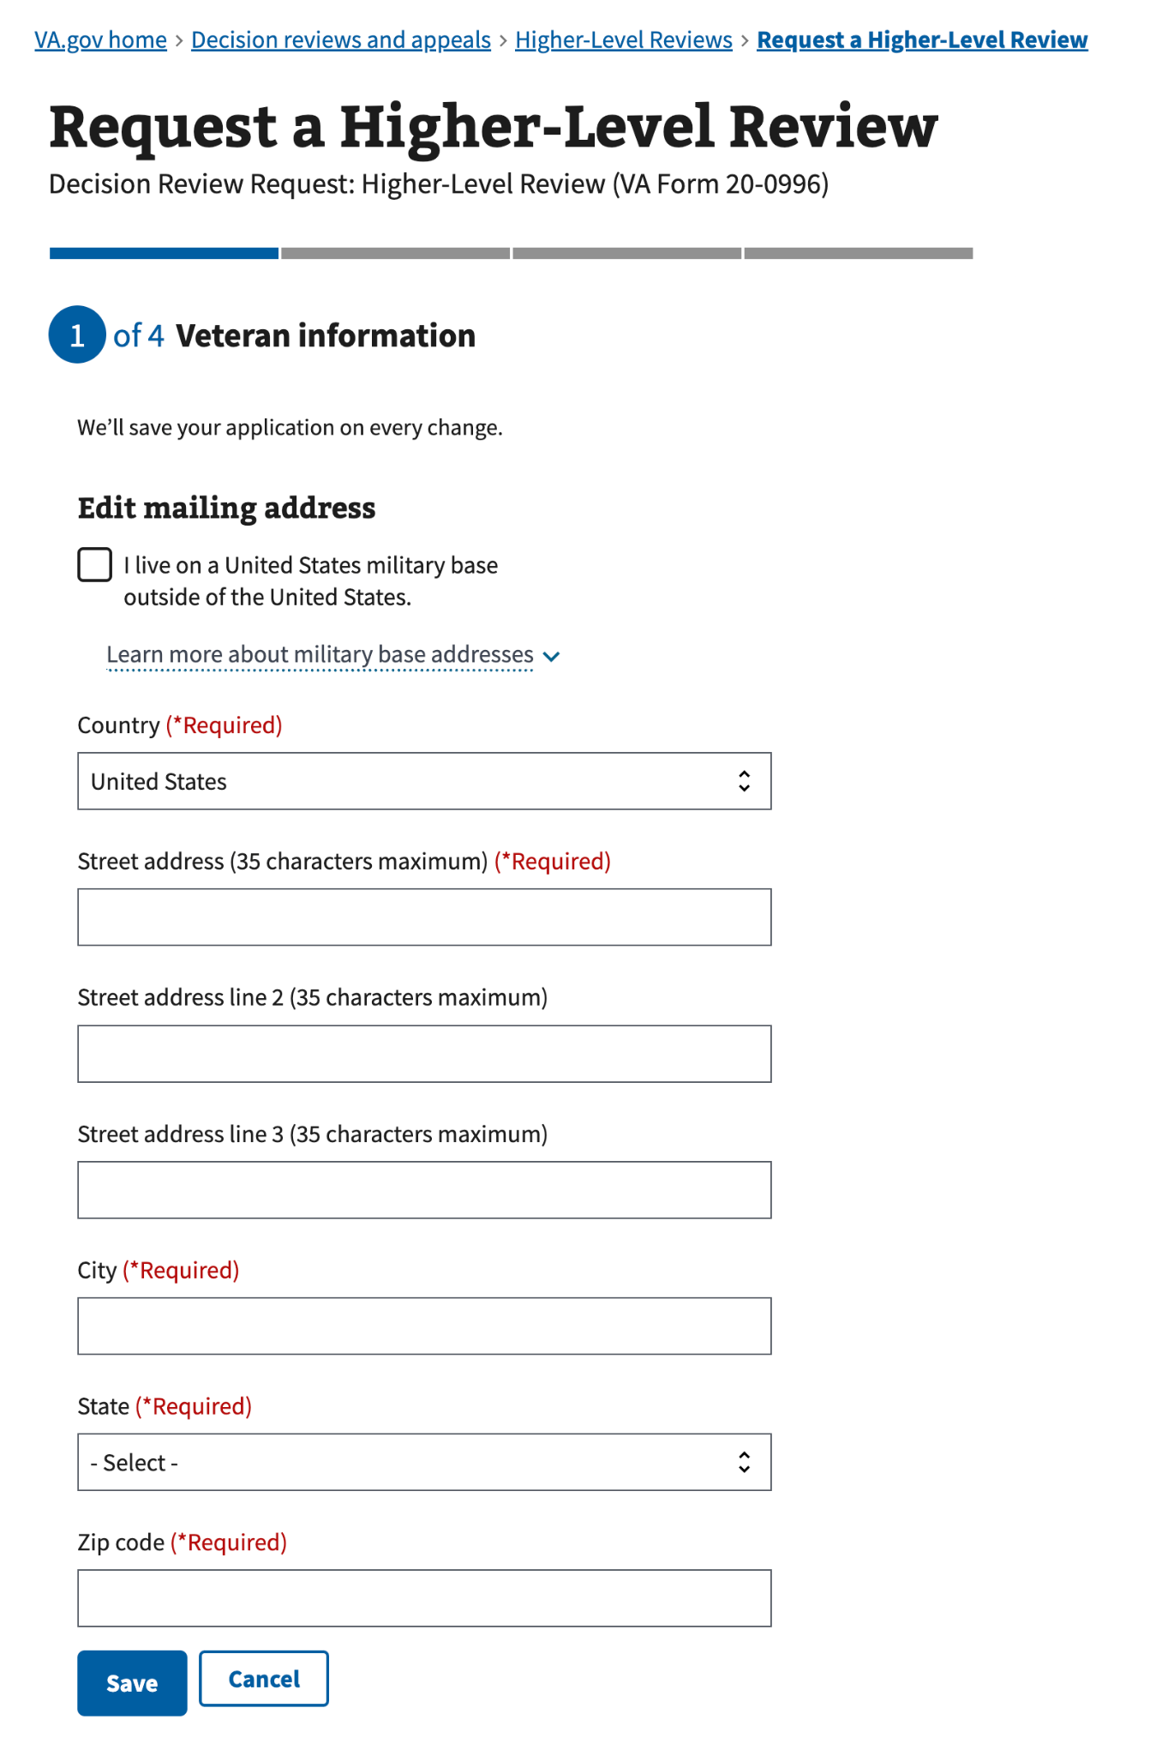

The fields are as follows:

| Field | Required |
| --- | --- |
| I live on a United States military base outside of the United States - unchecked | No |
| Country | Yes |
| Street address (35 characters maximum) | Yes |
| Street address line 2 (35 characters maximum) | No |
| Street address line 3 (35 characters maximum) | No |
| City | Yes |
| State | Yes |
| Zip code | Yes |

The fields will be prefilled with the mailing address that already exists within the user’s profile.

Selecting the “Save” button will update their mailing address within their profile, then return them to the contact information summary page.

Selecting the “Cancel” button will ignore any changes made to the input and not update their profile, then return them to the contact information summary page.

###### State 2 – Checked I live on a United States military base checkbox

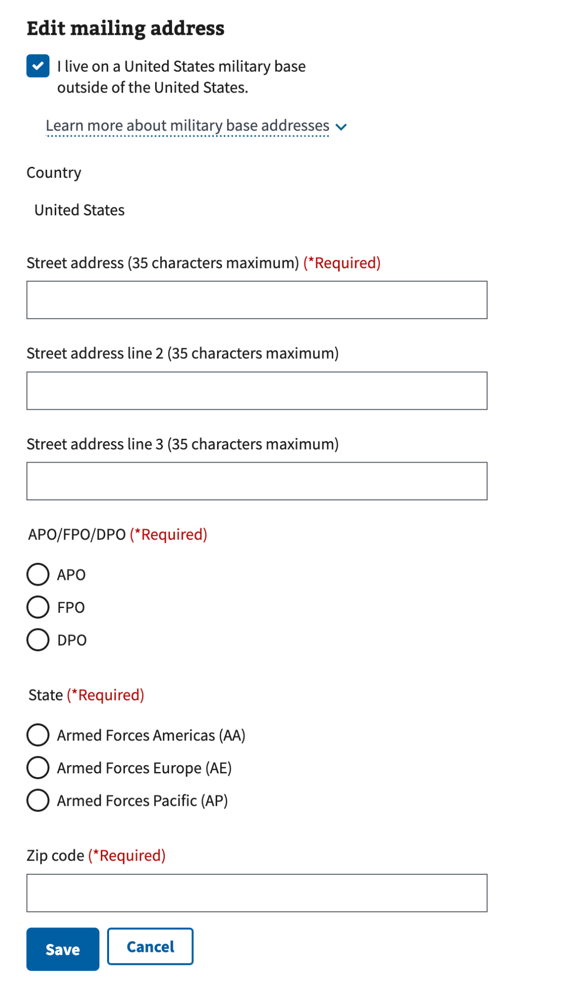

The fields are as follows:

| Field | Required |
| --- | --- |
| I live on a United States military base outside of the United States - checked | No |
| Street address (35 characters maximum) | Yes |
| Street address line 2 (35 characters maximum) | No |
| Street address line 3 (35 characters maximum) | No |
| APO/FPO/DPO | Yes |
| State | Yes |

The fields will be prefilled with the mailing address that already exists within the user’s profile.

Selecting the “Save” button will update their mailing address within their profile, then return them to the contact information summary page.

Selecting the “Cancel” button will ignore any changes made to the input and not update their profile, then return them to the contact information summary page.

### Issues for review

#### State changes

##### State 1 – The user has only API-loaded contestable issues visible

The user will select the issues they wish to contest for the Higher Level Review.

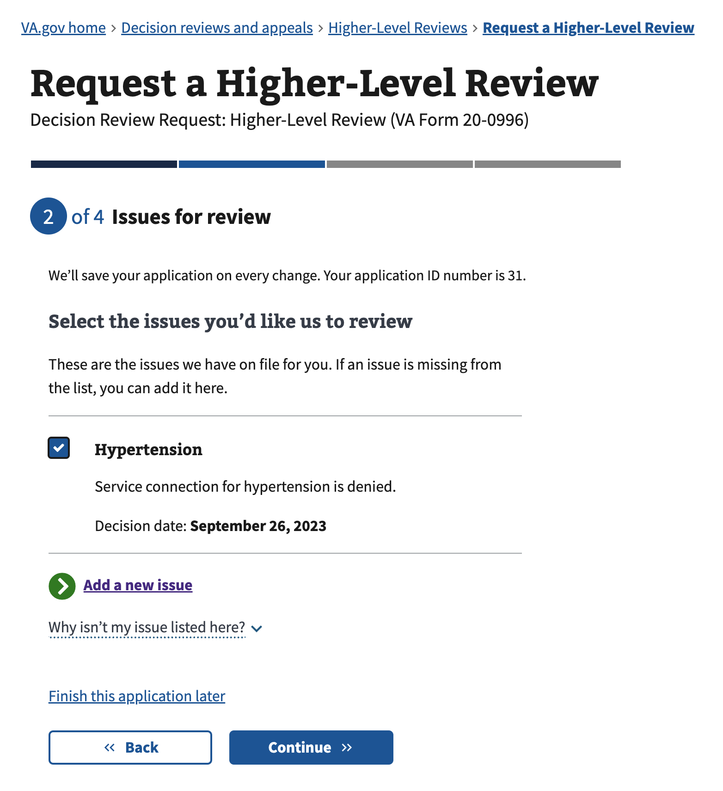

The fields are as follows:

| Field | Required |
| --- | --- |
| Contestable issue (user must select at least one from the list) - checkbox | Yes |

**Note:**

* Issues loaded from the API that have a decision date that is more than one year in the past will not be shown.
* Issues loaded from the API that include the key words “deferred”, “apportionment”, or “attorney fees” will not be shown as they would disqualify the request
* More than 100 issues may be visible on the page, but a maximum of 100 issues may be selected

##### State 2 – The user has API-loaded contestable issues and manually added issues visible, or only manually added issues

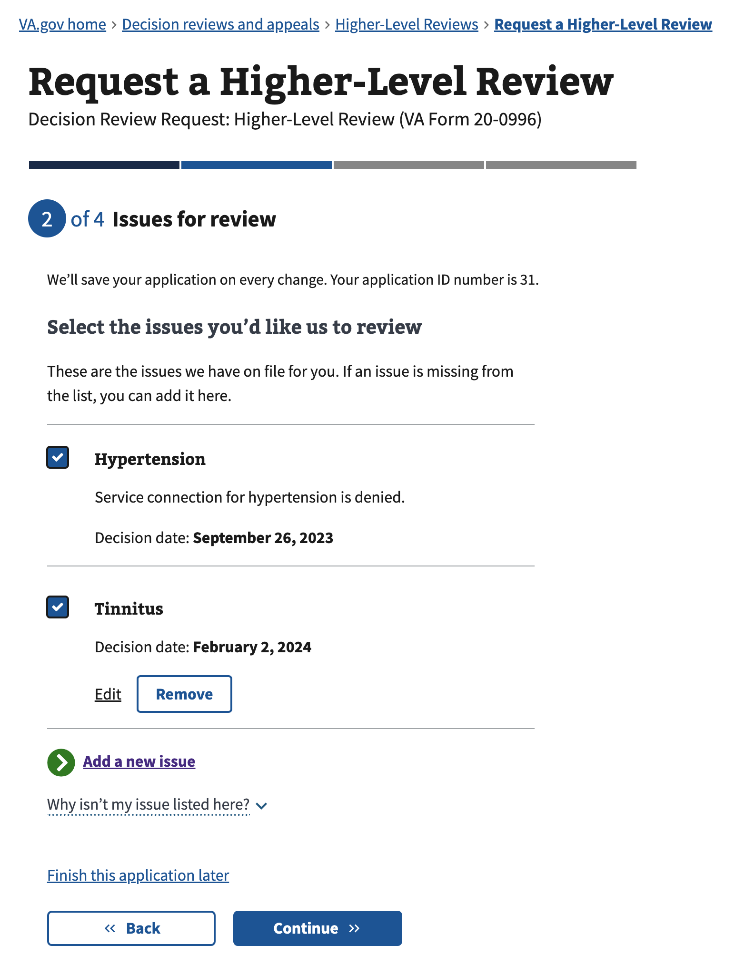

The fields are as follows:

| Field | Required |
| --- | --- |
| Contestable issue (user must select at least one from the list) - checkbox | Yes |

The “Edit” link and “Remove” remove button are only visible for issues that are manually added.

Using the “Edit” link will direct the user to ‘Add an issue’ allowing them to make edits to an issue.

Using the “Remove” link will open a modal asking the user if they are sure they want to remove the issue.

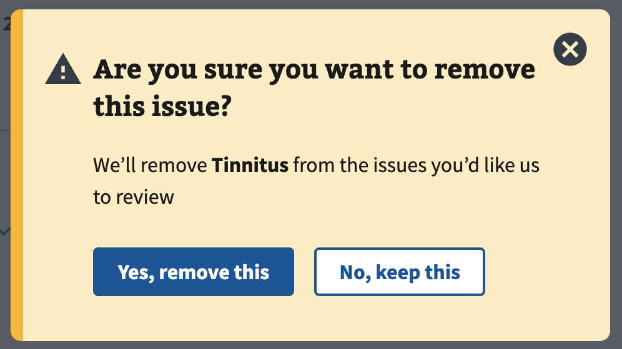

Selecting “Yes, remove this” will close the modal and remove the associated issue.

Selecting “No, keep this” will close the modal and keep the associated issue.

### 

#### Add an issue

On the previous page, if the user selects the “Add a new issue” action link, they will be directed to the following page.

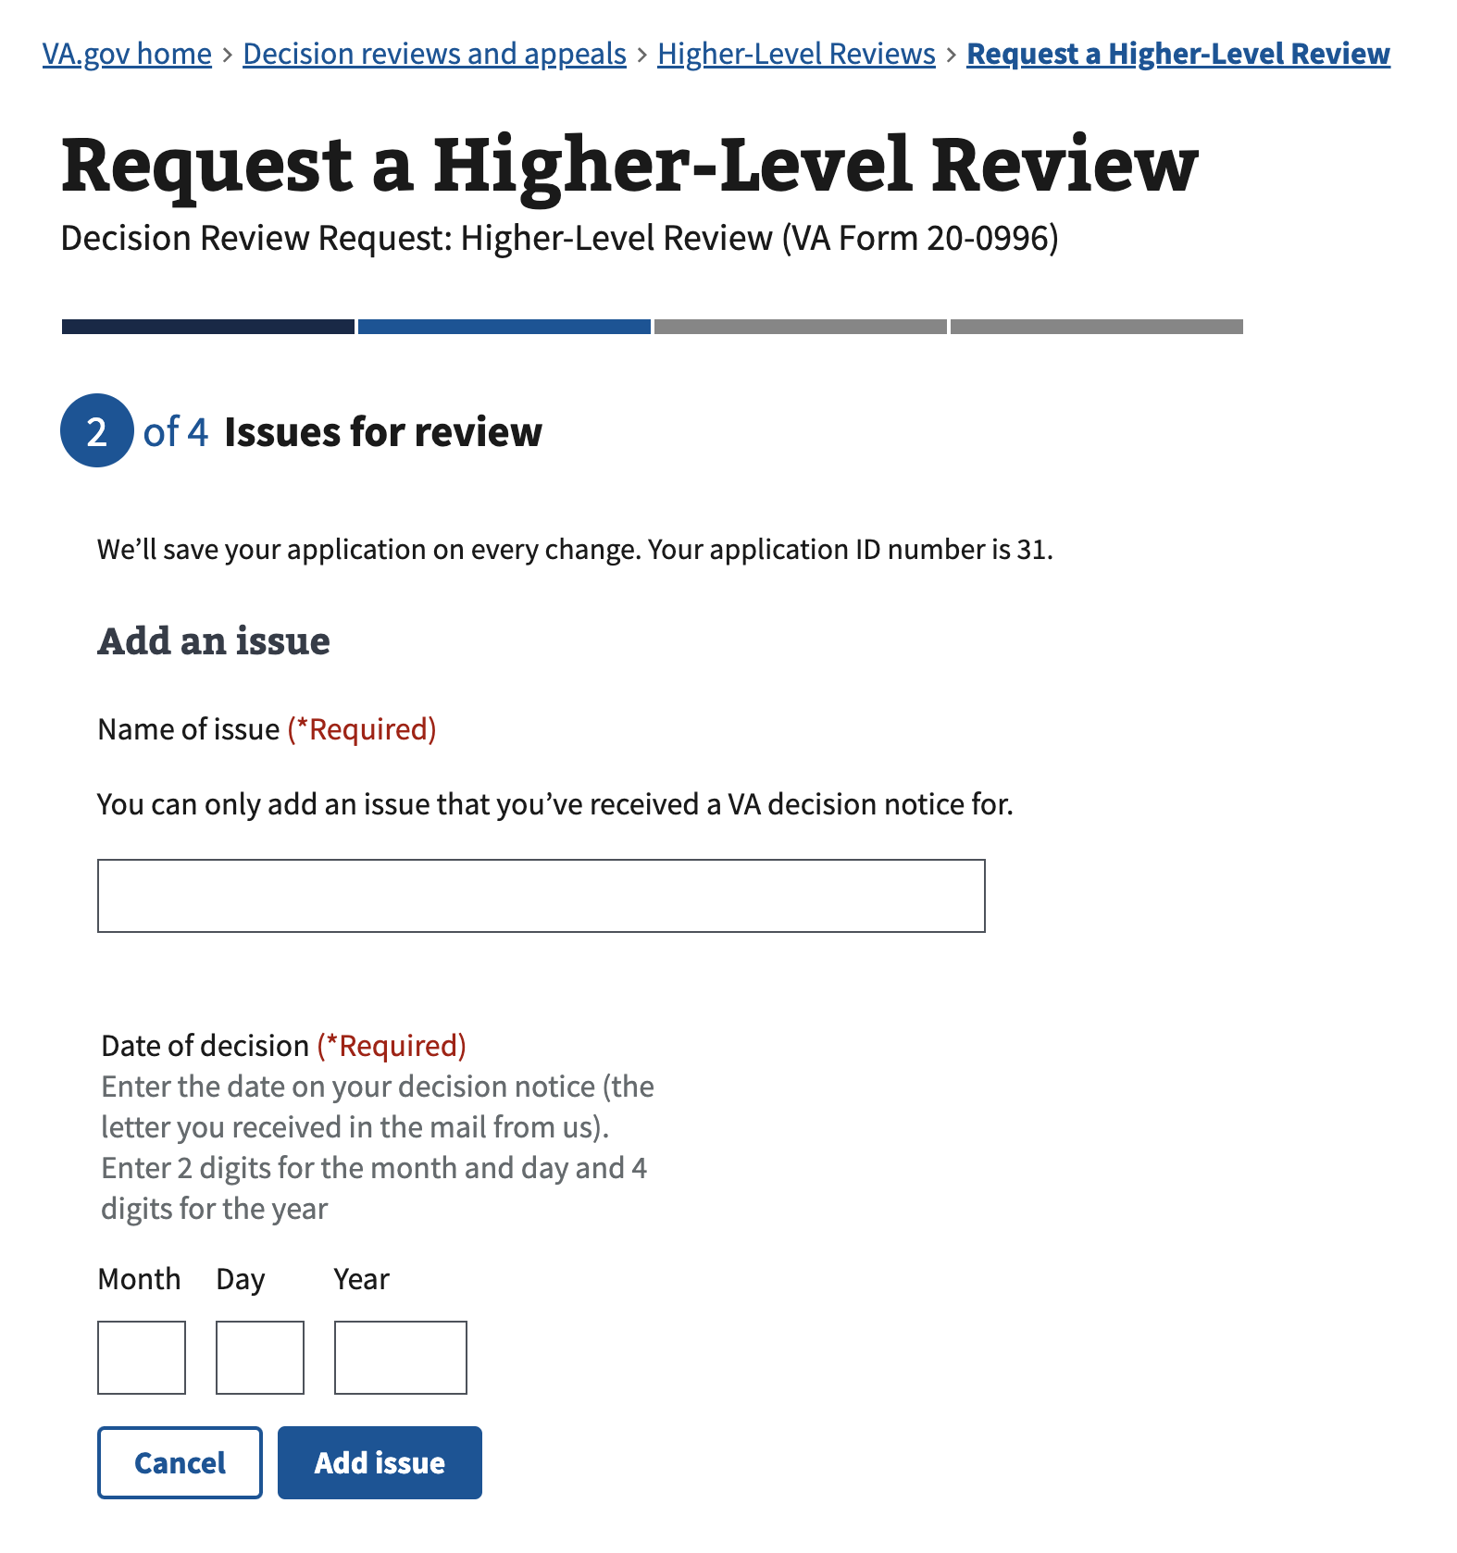

The fields are as follows:

| Field | Required |
| --- | --- |
| Name of issue | Yes |
| Date of decision, month | Yes |
| Date of decision, day | Yes |
| Date of decision, year | Yes |

The issue name and date of decision must be unique within the list. Duplicate entries will be blocked from addition.

The date of decision will only allow entering a date:

* That is less than one year in the past
* Not today’s date
* Not any date in the future

Selecting the “Cancel” button will ignore any changes made to the inputs and not add the issue, then return them to the issues summary page.

Selecting the “Add issue” or “Update issue” button will add the issue, then return them to the “Issues for review” page.

### 

### Areas of disagreement

For each selected issue on the previous page, an area of disagreement page will ask which part of the decision the user disagrees with.

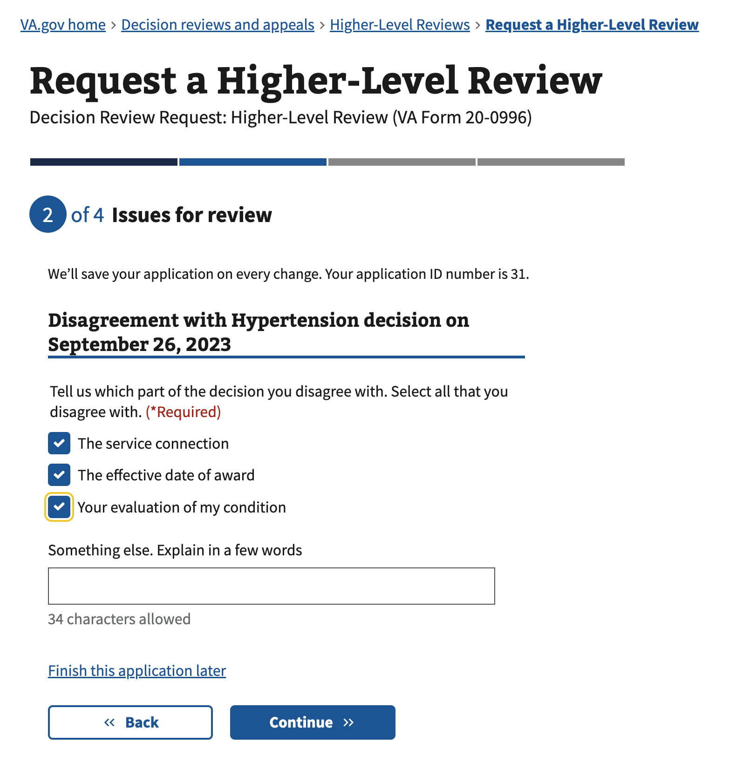

The fields are as follows:

| Field | Required |
| --- | --- |
| The service connection | Yes - one selection, or some text required |
| The effective date of award | Yes - one selection, or some text required |
| Your evaluation of my condition | Yes - one selection, or some text required |
| Something else. Explain in a few words | Yes - one selection, or some text required |

The “Something else” text input will only allow a limited number of characters. It will change based on the checkbox selections. The maximum number of characters for the input, with no checkboxes checked, is 90 characters. With all checkbox selections, the input will only allow 34 characters.

### Authorization to move to the current decision review process

This page describes the fact that submitting this online application will move any legacy issues they are requesting a review for into the current decision review process.

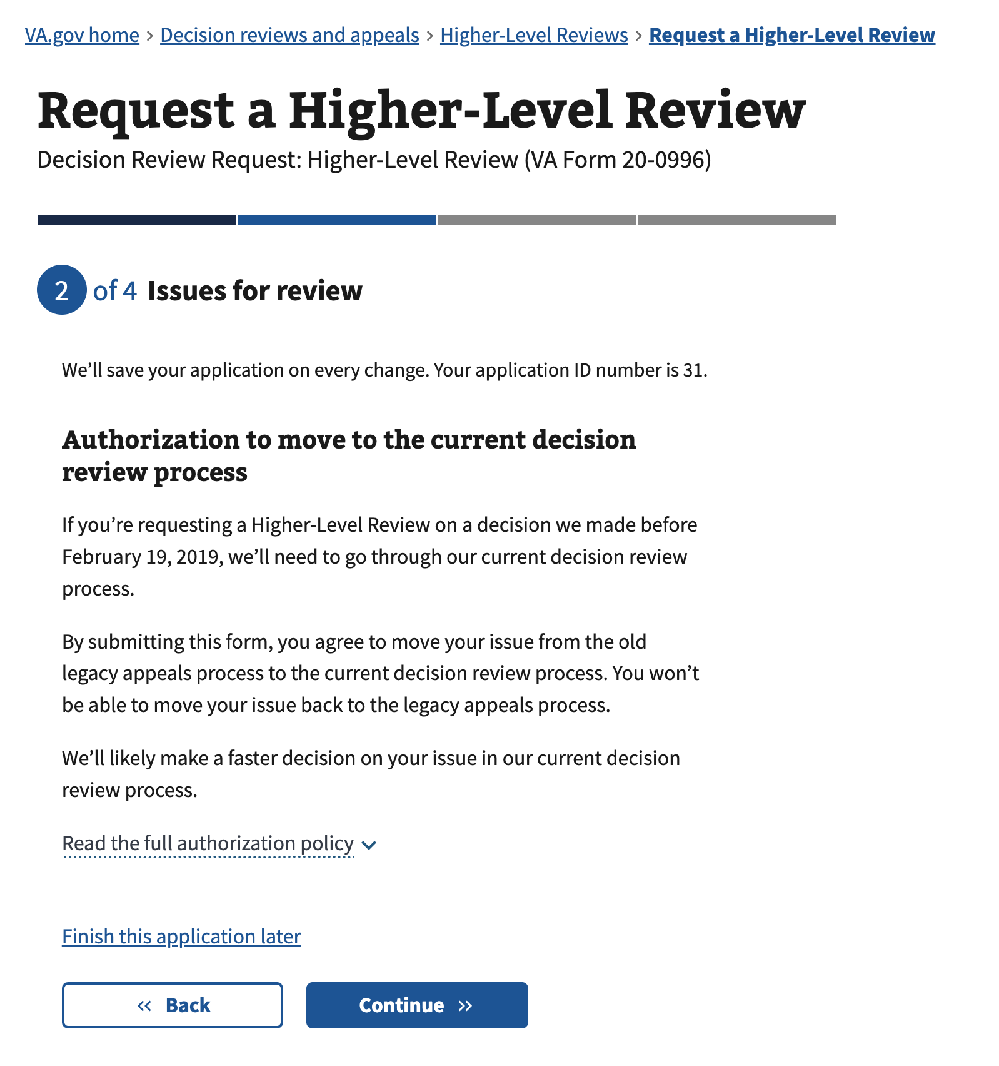

The only form actions a user can take on this page are to either go back or continue.

### Issue summary

This summary page shows the issues that were selected and provides the user a link to return to the issues for review page.

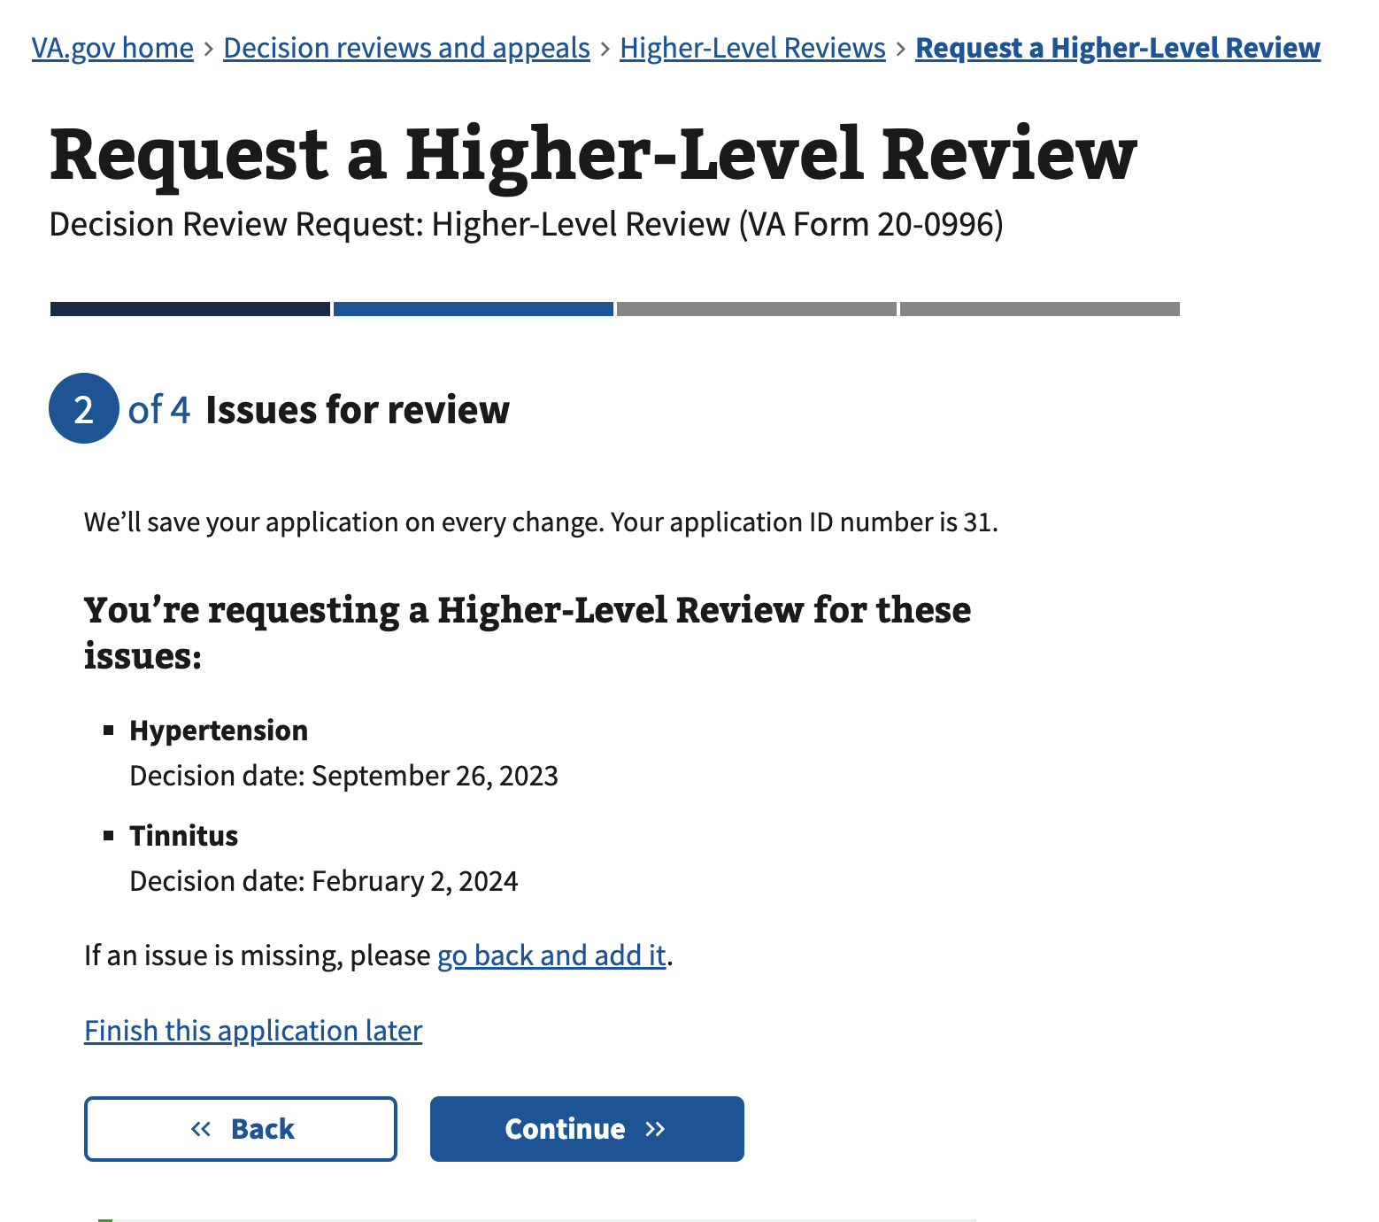

The only form actions a user can take on this page are to either go back or continue.

### 

### Option to request an informal conference

The user has the option to request an informal conference. The user has ‘yes’ or ‘no’ options in response:

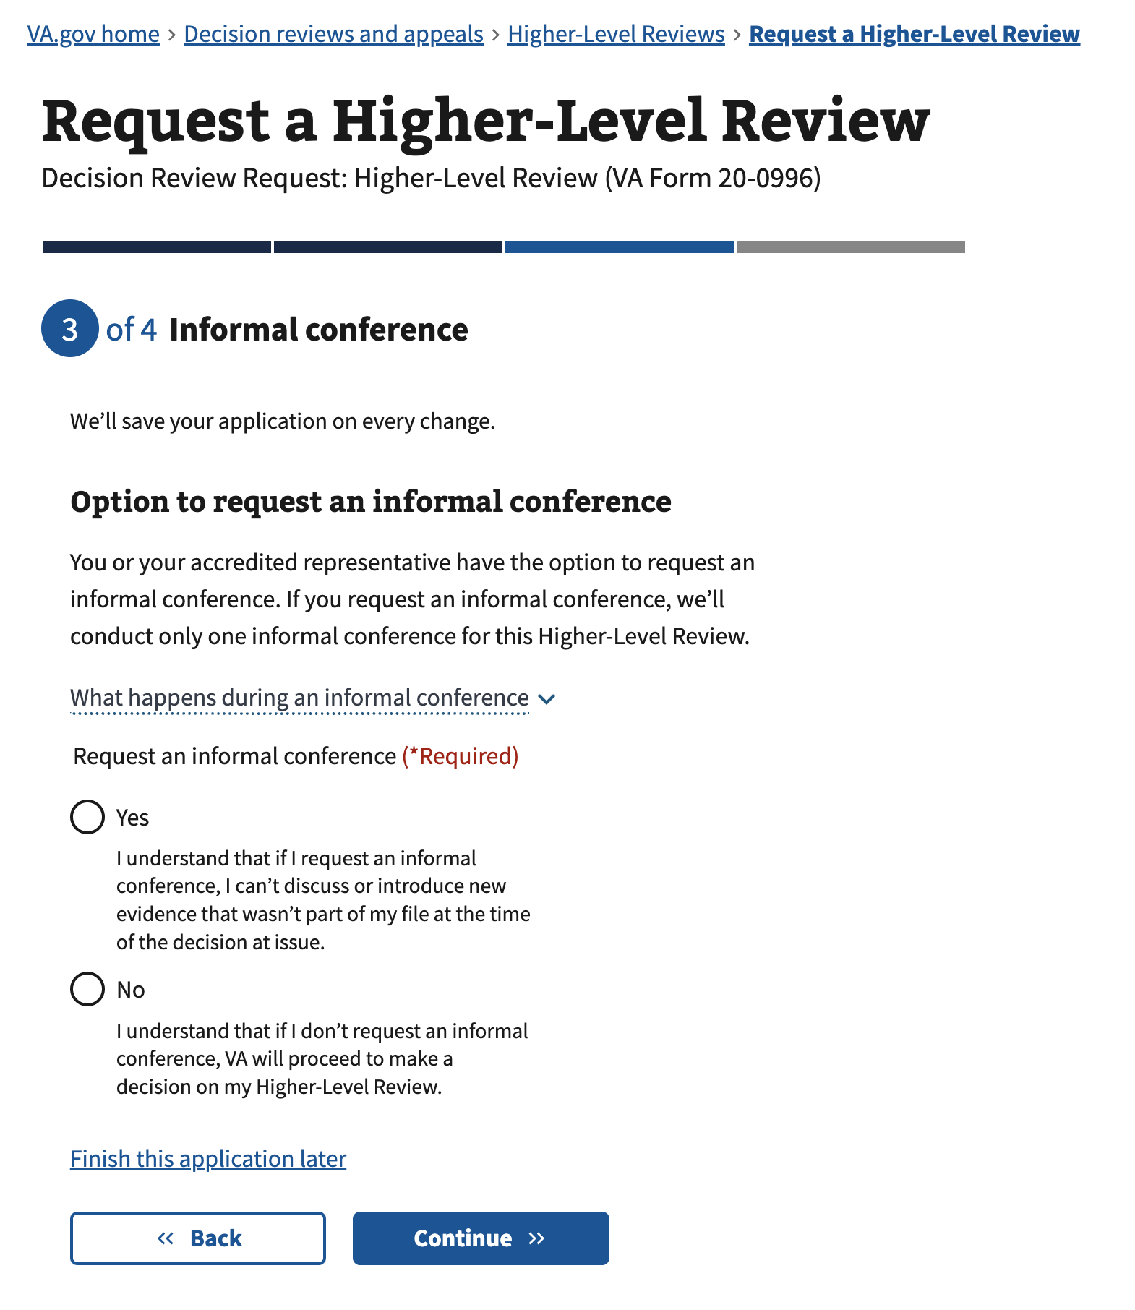

The fields are as follows:

| Field | Required |
| --- | --- |
| Yes | Yes – one selection required |
| No | Yes – one selection required |

#### State changes

##### Option 1 - Yes

The user will be asked additional questions regarding who to contact and the times range that they would be available for a call to schedule an informal conference (this is NOT the informal conference itself)

##### 

##### Option 2 – No

There is no further requirement from the user. Selecting the continue button will direct the user to the review and submit page.

### Scheduling your informal conference

If the user selected ‘yes’ in the previous step, they are shown this question. The user is asked who to contact to schedule the informal conference. The user has ‘Contact me’ and ‘Contact my accredited representative’ as a response.

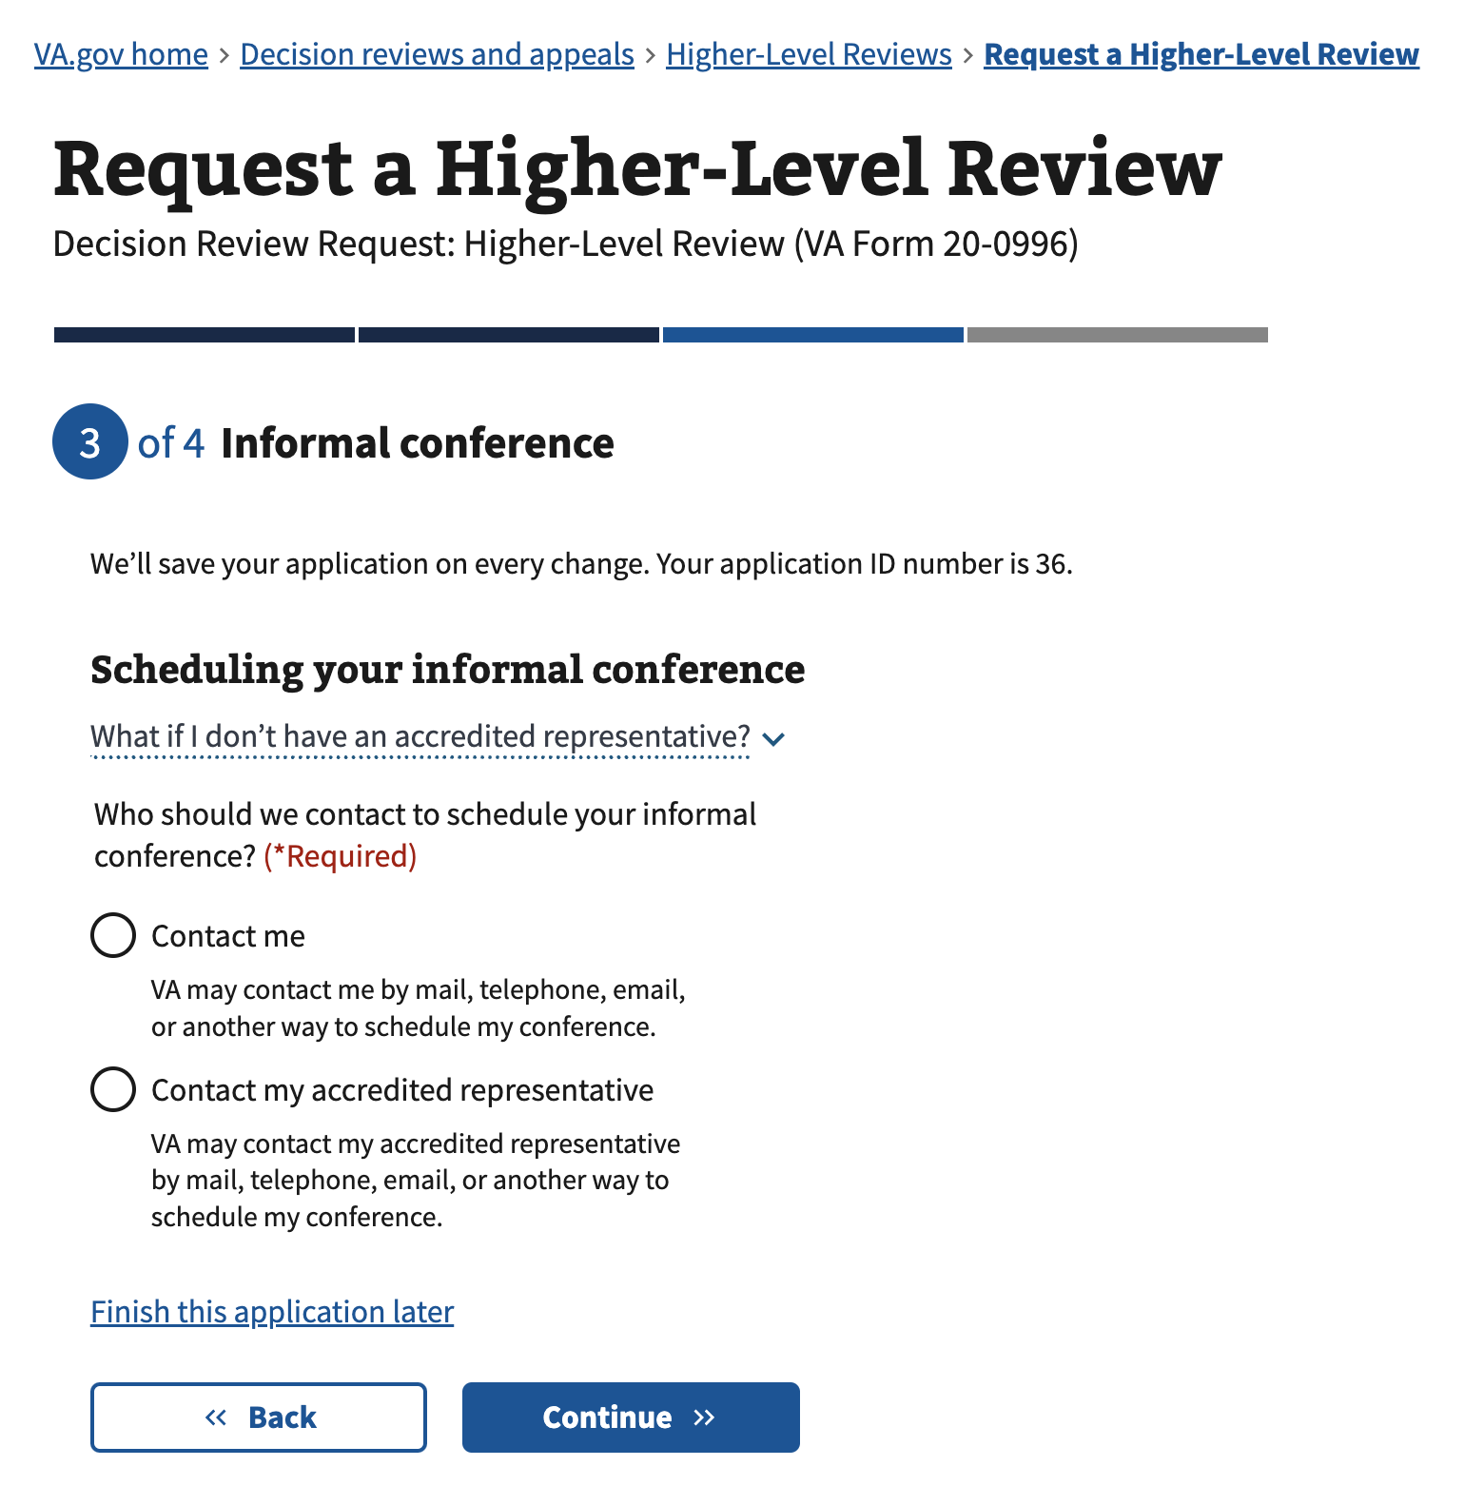

The fields are as follows:

| Field | Required |
| --- | --- |
| Contact me | Yes – one selection required |
| Contact my accredited representative | Yes – one selection required |

#### State changes

##### Option 1 - Contact me

The user will be asked the time range that they would be available for a call to schedule the informal conference.

##### Option 2 – Contact my accredited representative

The user will be asked for their accredited representative’s name and contact information, they will then be asked for the time range that their accredited representative would be available for a call to schedule the informal conference.

### 

### 

### Best time for us to call you

This additional question is shown if the “Scheduling your informal conference” choice was set to ‘Contact me’.

The user will be asked the time range that they would be available for a call to schedule the informal conference

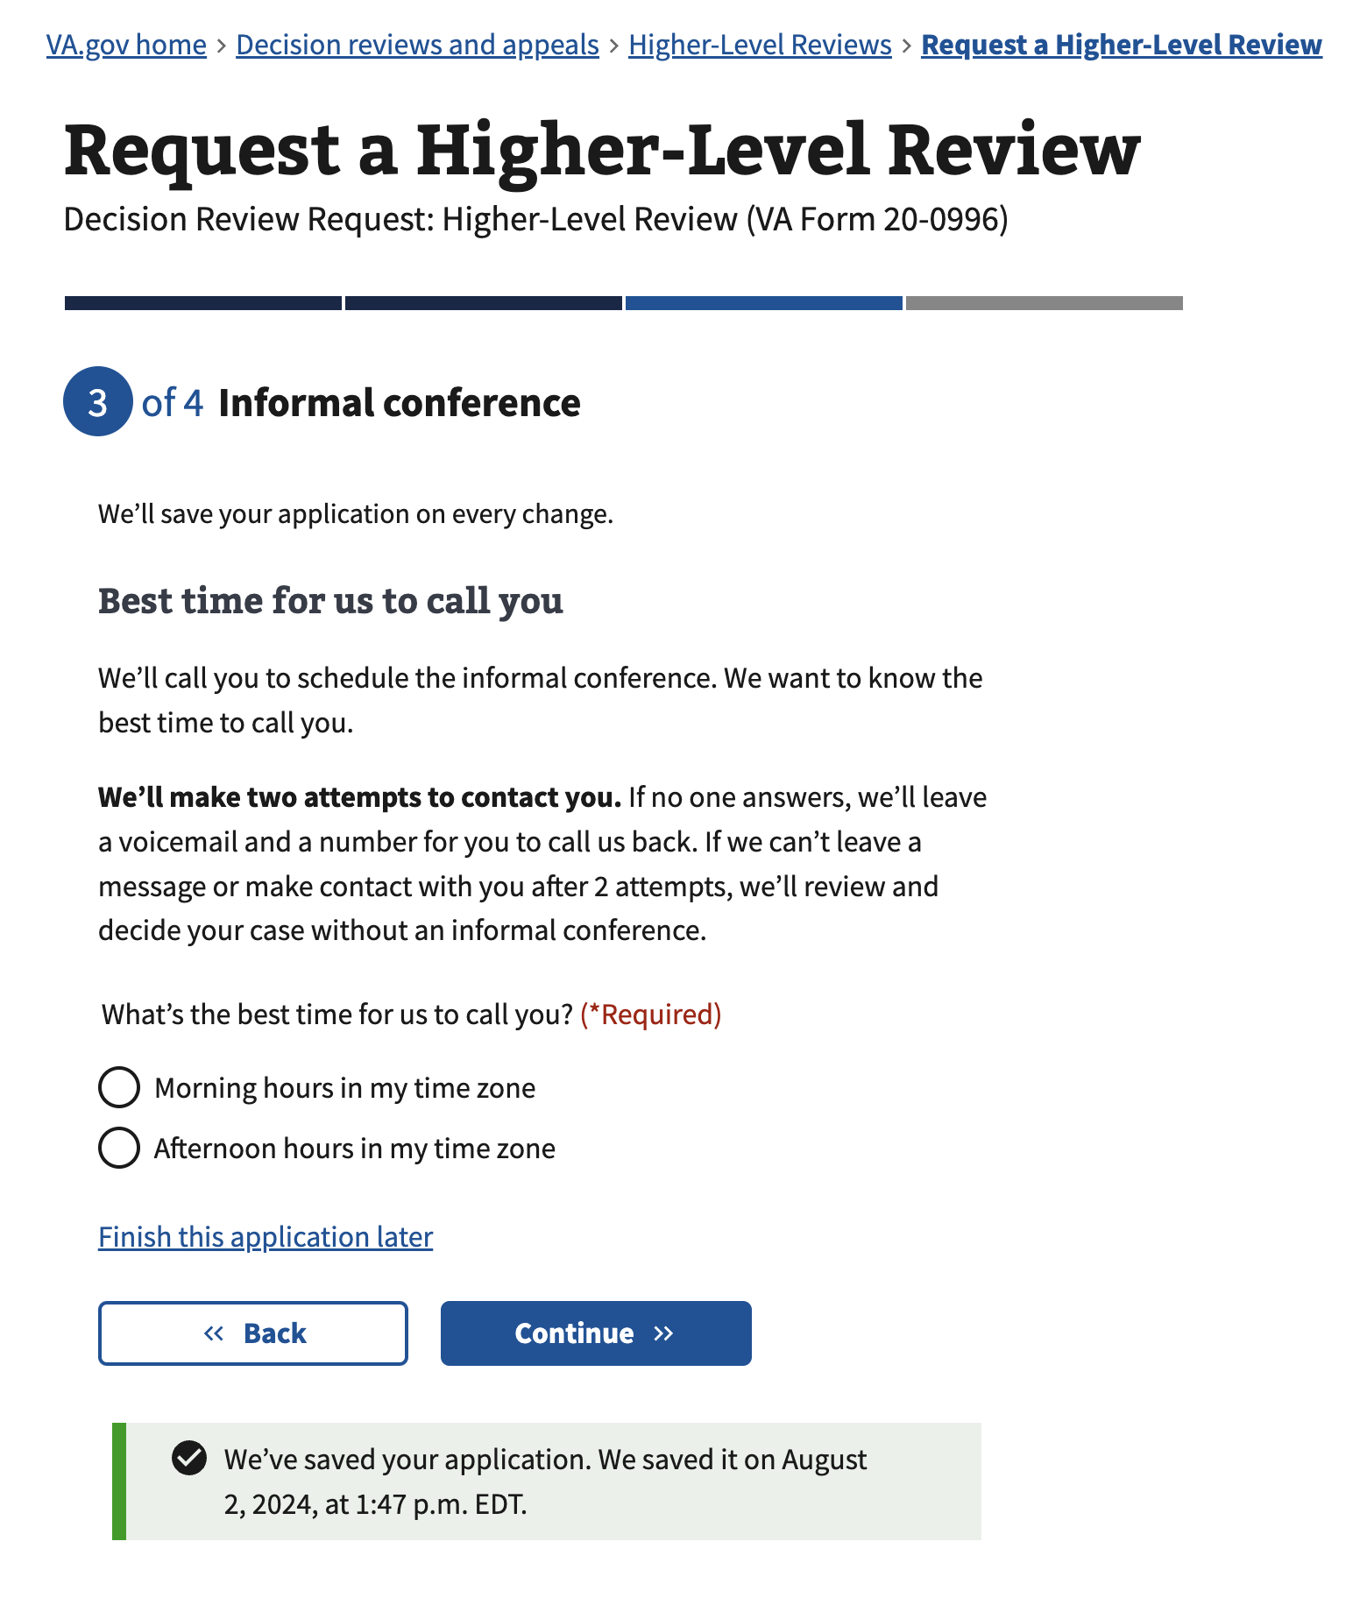

The fields are as follows:

| Field | Required |
| --- | --- |
| Morning hours in my time zone | Yes – one selection required |
| Afternoon hours in my time zone | Yes – one selection required |

### 

### Your representative’s contact information

This additional question is shown if the “Scheduling your informal conference” choice was set to ‘Contact my accredited representative’.

The user will be asked for their accredited representative’s name and contact information, they will then be asked for the time range that their accredited representative would be available for a call to schedule the informal conference

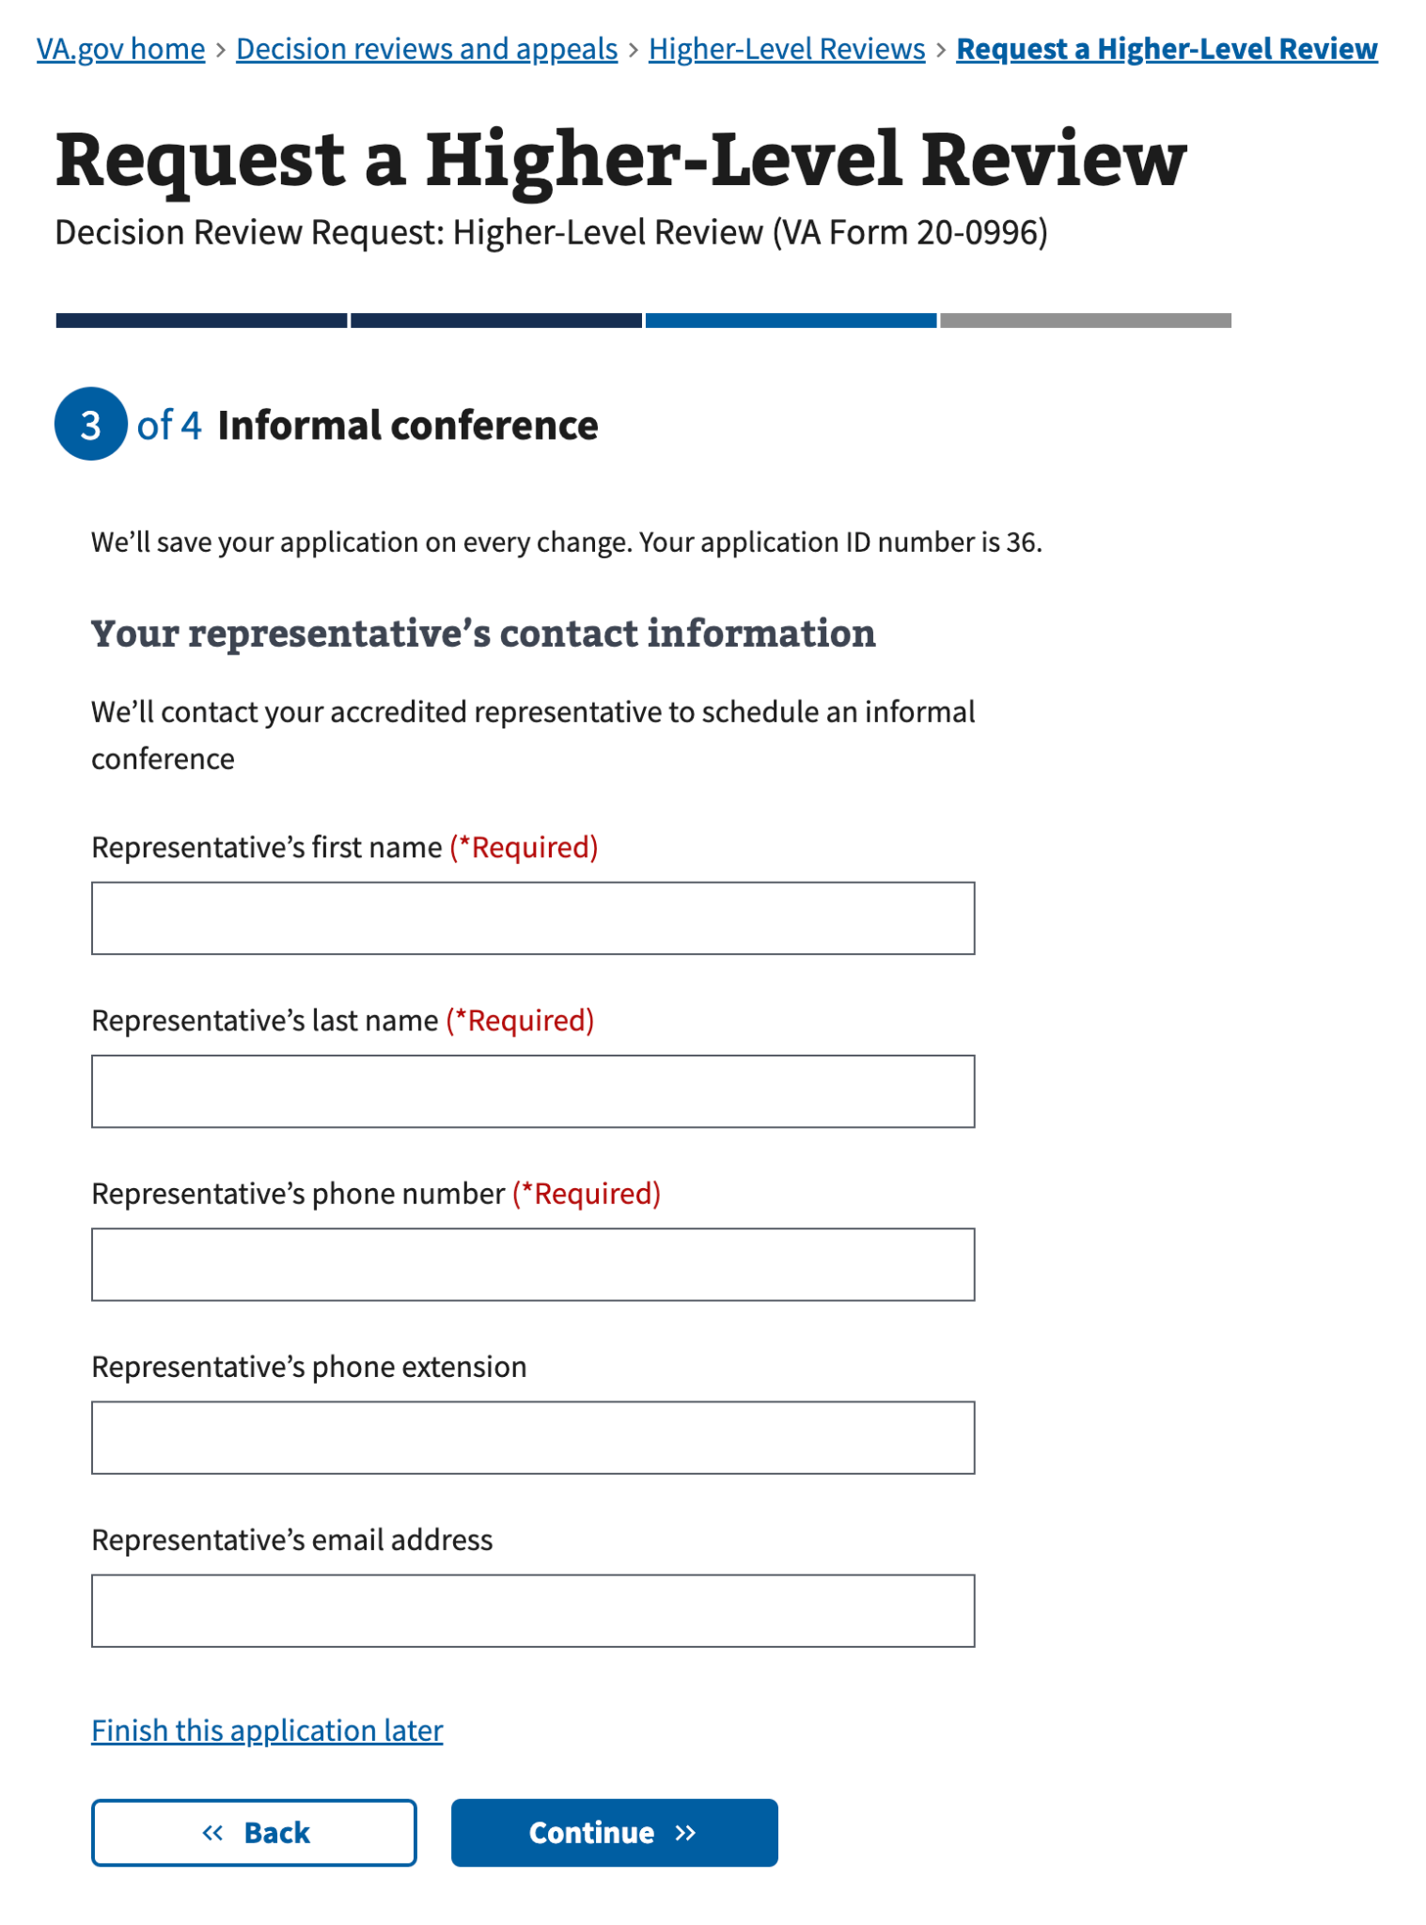

The fields are as follows:

| Field | Required |
| --- | --- |
| Representative’s first name | Yes |
| Representative’s last name | Yes |
| Representative’s phone number | Yes |
| Representative’s phone extension | No |
| Representative’s email address | No |

### 

### Best time for us to call your accredited representative

This additional question is shown after “Your representative’s contact information” if the “Scheduling your informal conference” choice was set to ‘Contact my accredited representative’. The user will be asked the time range that their accredited representative would be available for a call to schedule the informal conference

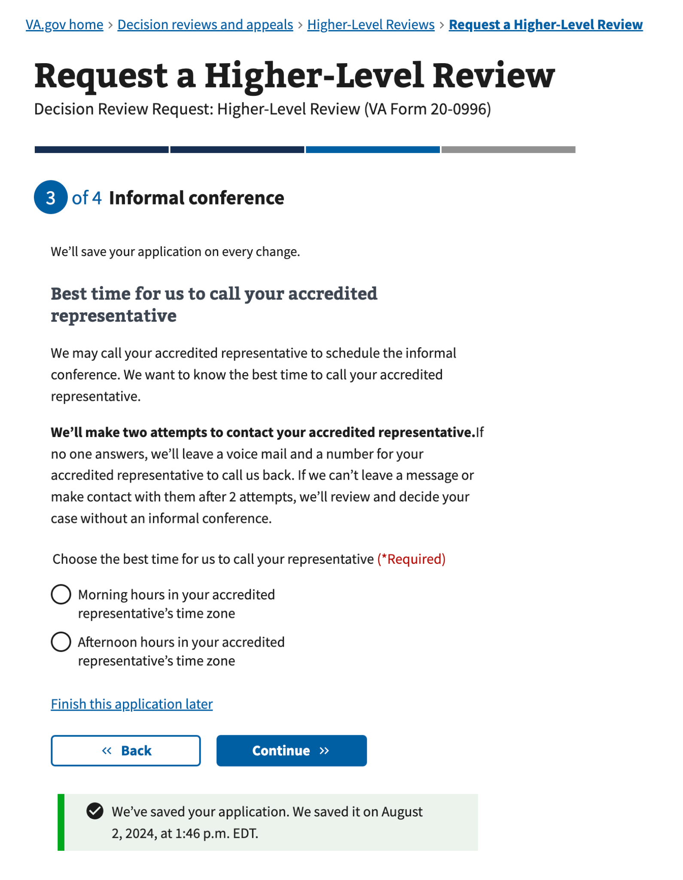

The fields are as follows:

| Field | Required |
| --- | --- |
| Morning hours in your accredited representative’s time zone | Yes – one selection required |
| Afternoon hours in your accredited representative’s time zone | Yes – one selection required |

## 

## Review application

The user has the opportunity to review the information and confirm the accuracy or edit as needed.

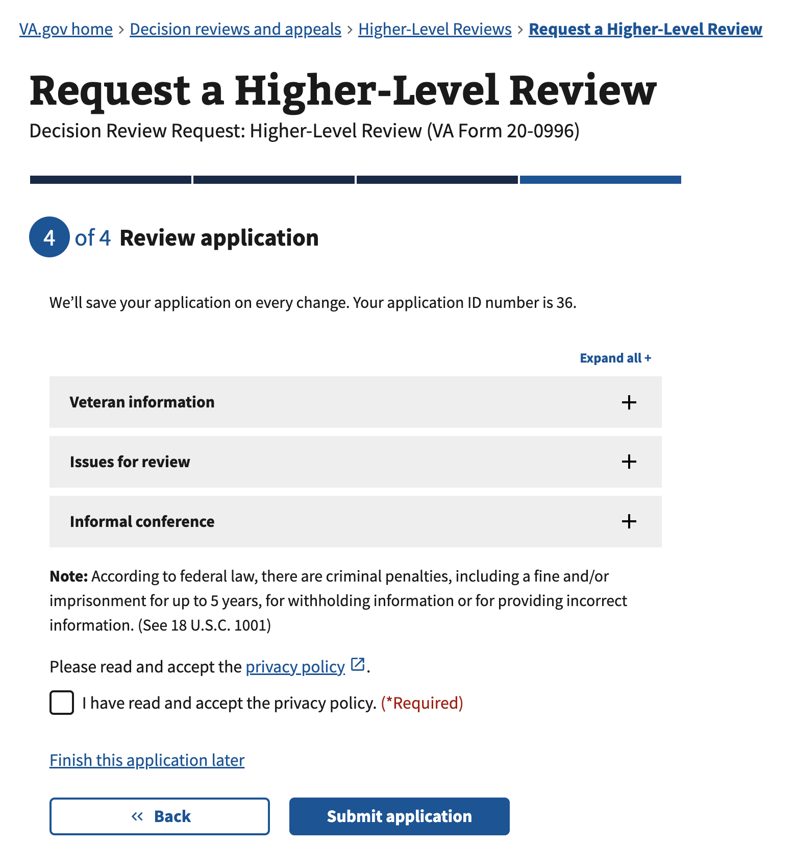

### State changes

The user is able to open each accordion on the review page.

#### 

#### Accordion - Veteran information

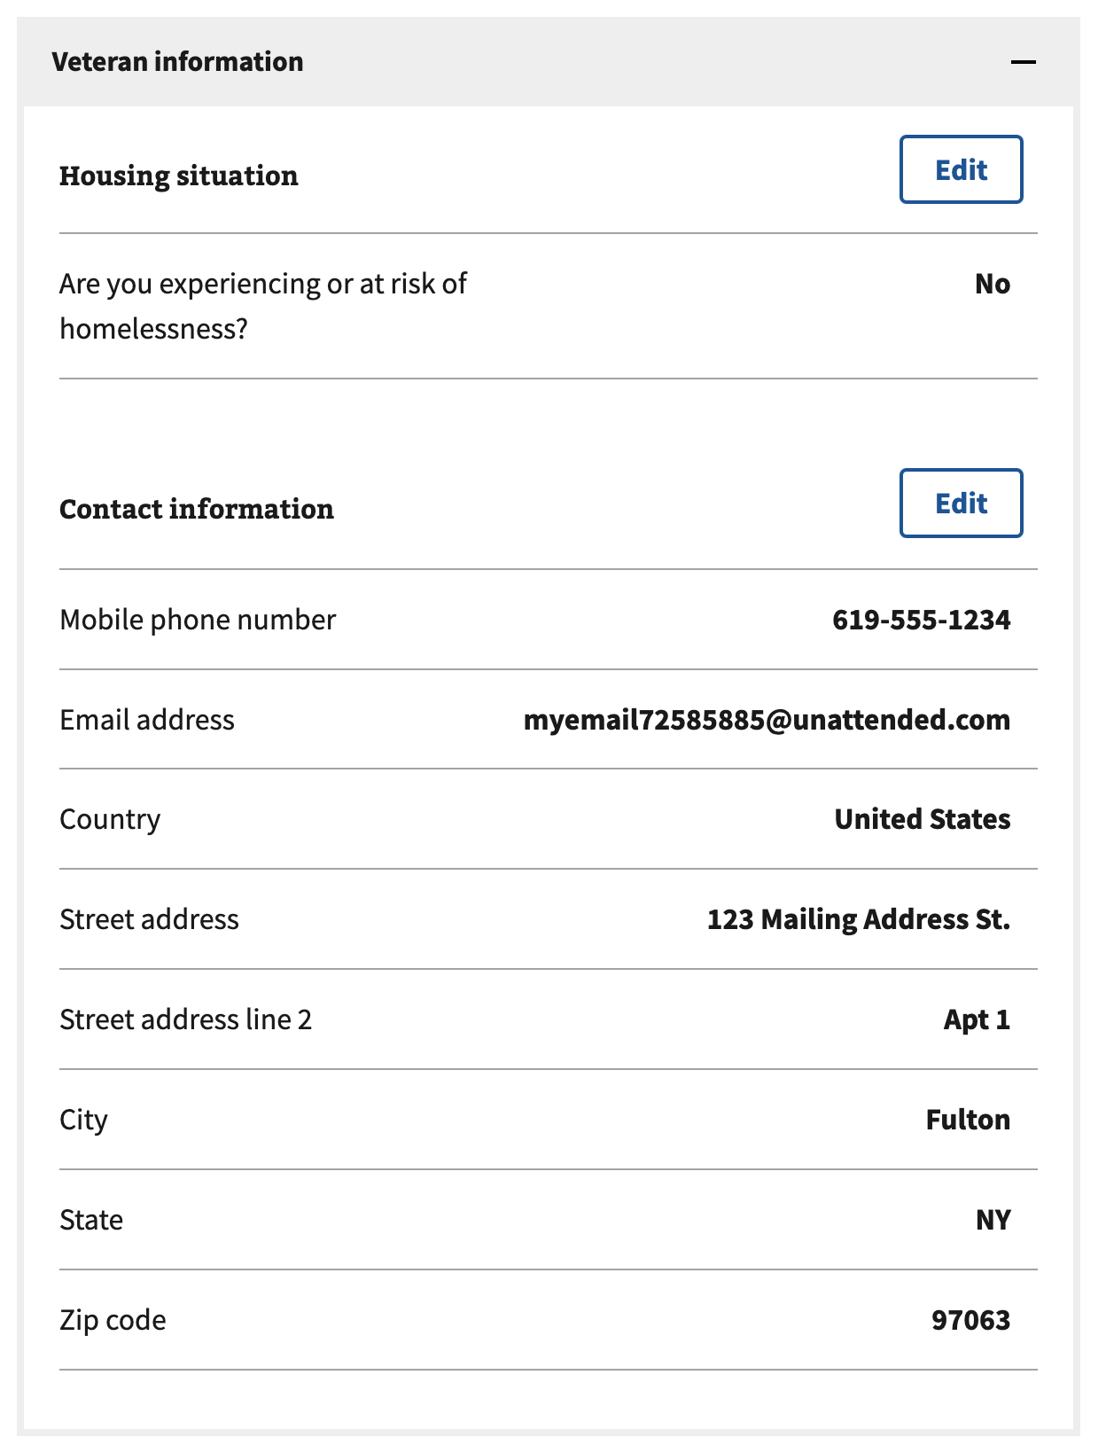

##### 

#### Housing situation - Edit

The user is able to select the edit button and change their housing situation choice. Field requirements are the same as ‘Housing situation’.

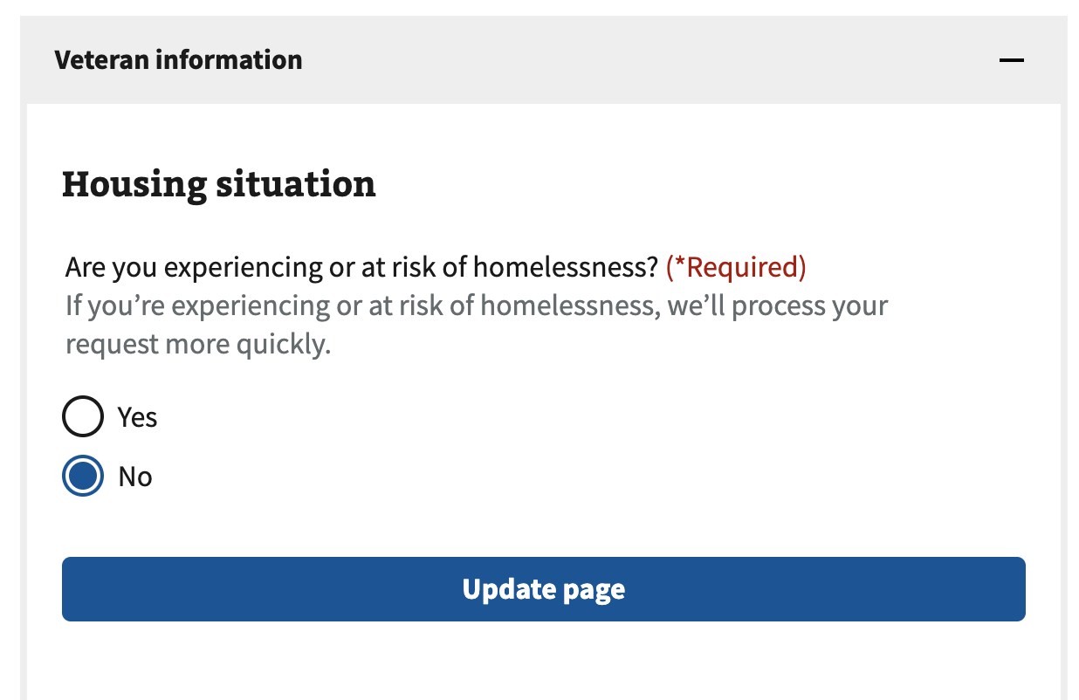

Once the edit is complete, the user can select the update page button to return to the previous view.

#### Contact information - Edit

After selecting the edit button, the user will see a summary of their contact information with edit links for mobile phone number, email address and mailing address. Field requirements are the same as ‘Contact information’.

When the user selects any of these edit links, they will be redirected to the associated edit pages. Once the user saves or cancels the changes on the edit pages, they will return to the review page and see the following view (again).

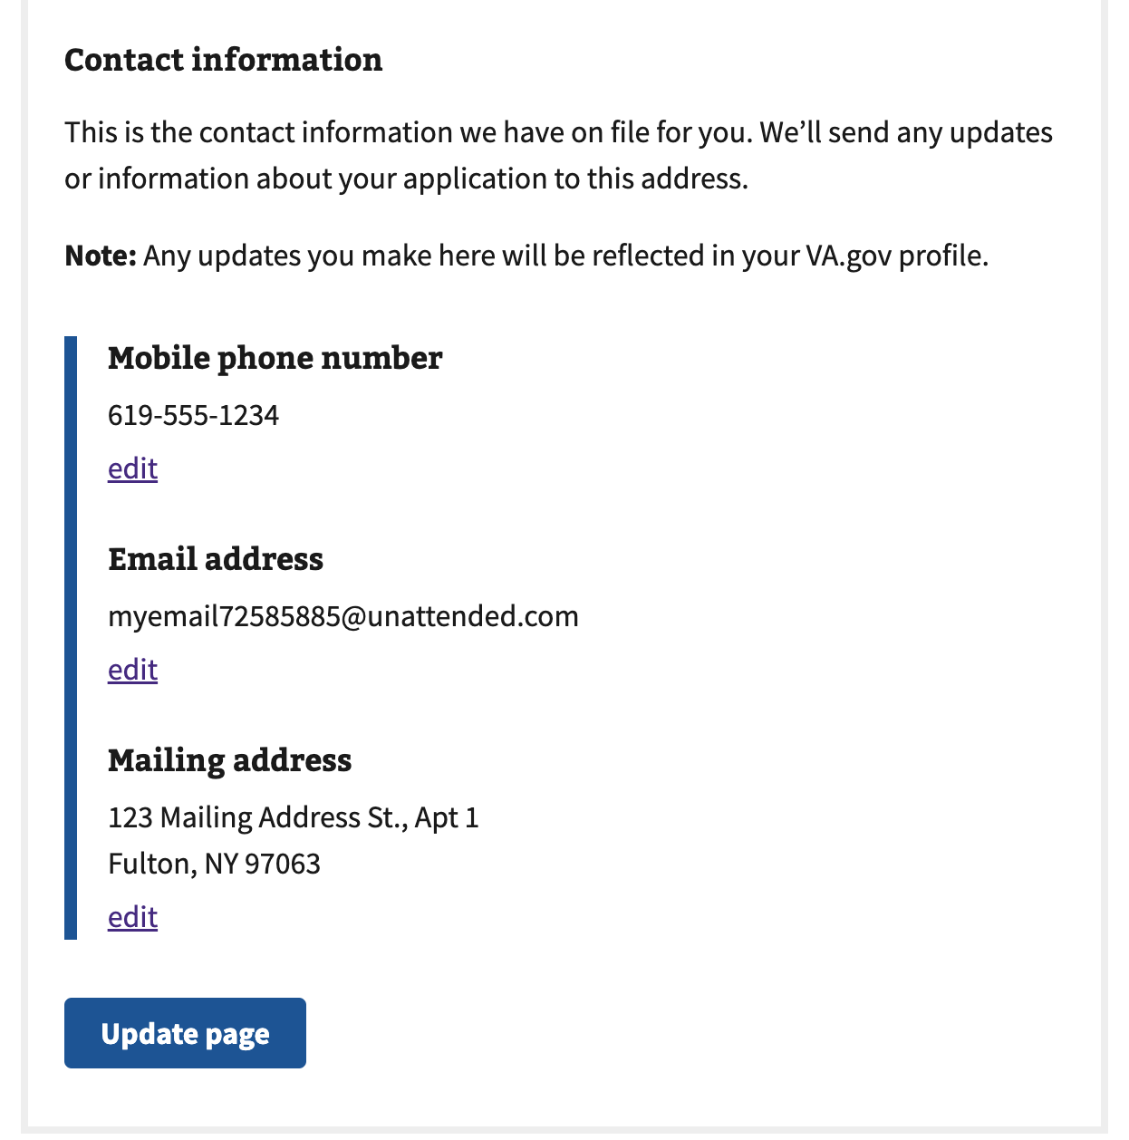

Once the edit is complete, the user can select the update page button to return to the previous view.

##### 

#### Accordion - Issues for review

The user is able to select the edit button and change their issues and disagreement choices

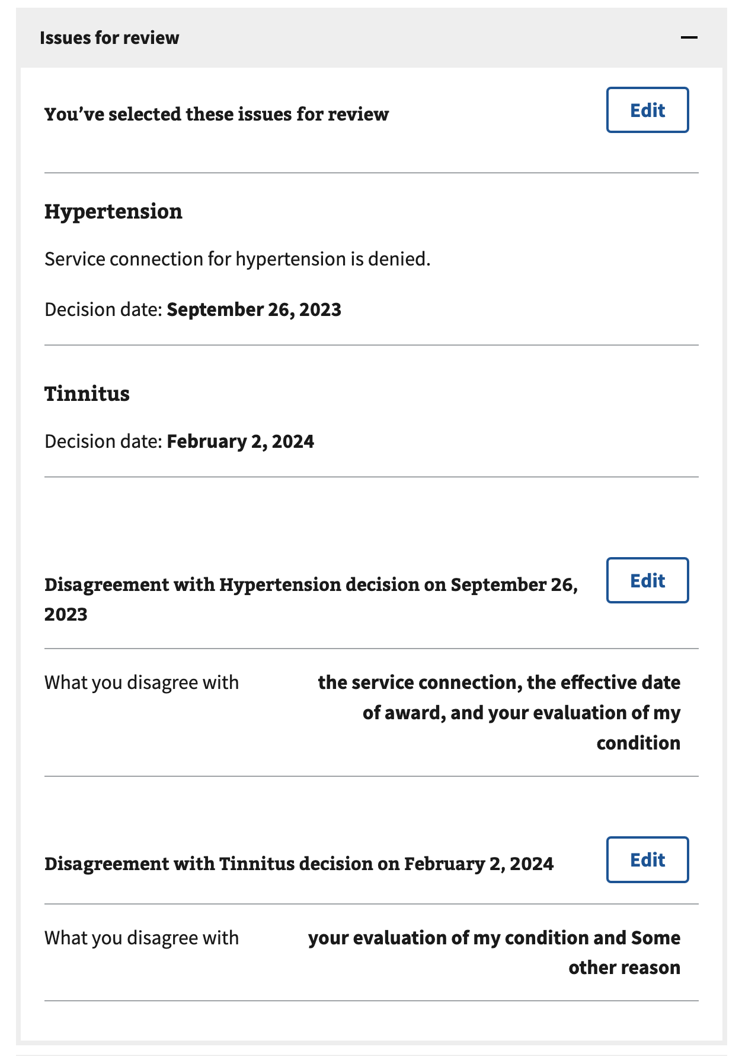

#### Contested Issues – Edit

The user is able to select the edit button and edit information as needed. Field requirements are the same as ‘Issues for review’. They can select, deselect or add issues.

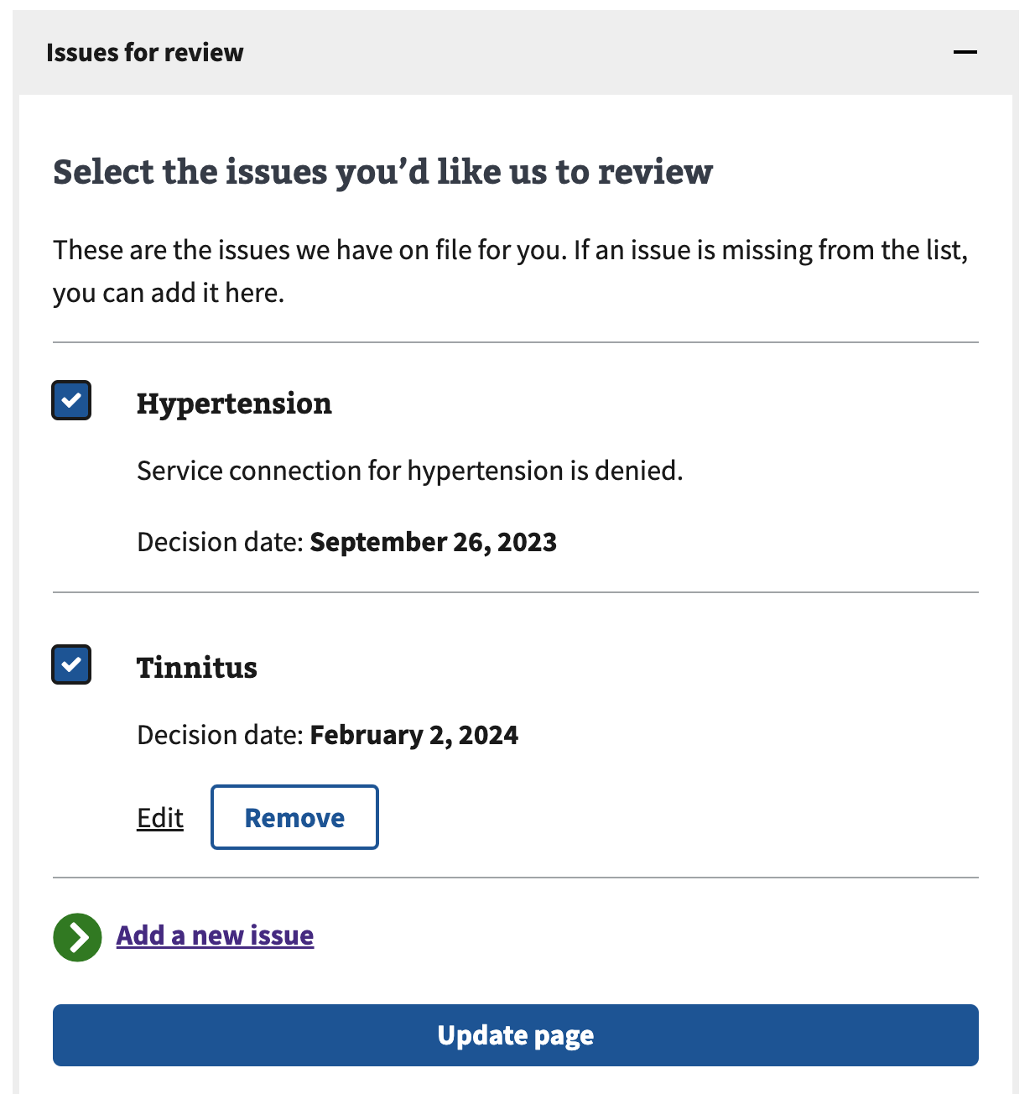

Once done, they can select “update page” to return to the previous view.

Adding and/or selecting issues will cause the accordion background to change to highlight that some information is missing; referring to the area of disagreement section needing to be updated

##### 

#### Area of Disagreement - Edit

The user is able to select the edit button and edit information as needed. Field requirements are the same as ‘Areas of disagreement’. They can select, deselect or change the input text.

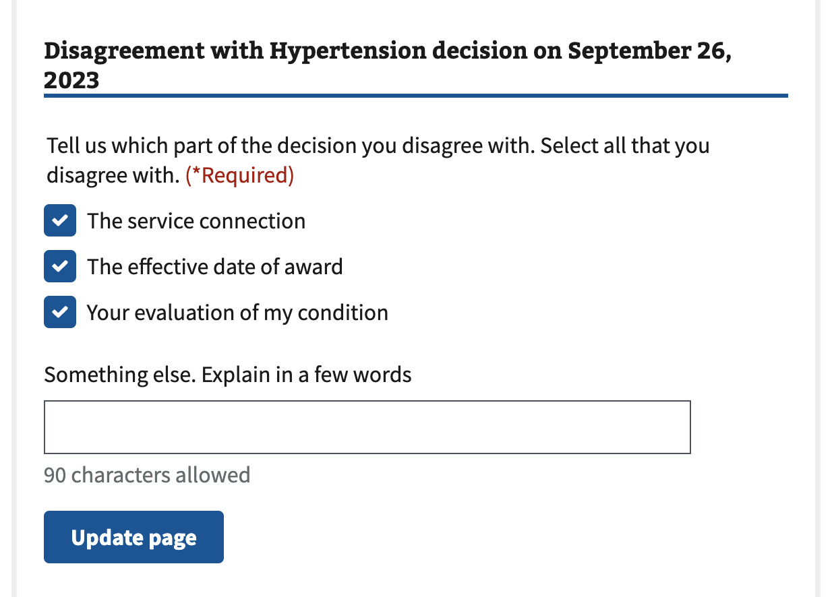

Once done, they can select “update page” to return to the previous view.

#### Accordion – Informal Conference

The user is able to select the edit button and change their informal conference choice, who to call for scheduling, representative information, and call availability choices (if applicable).

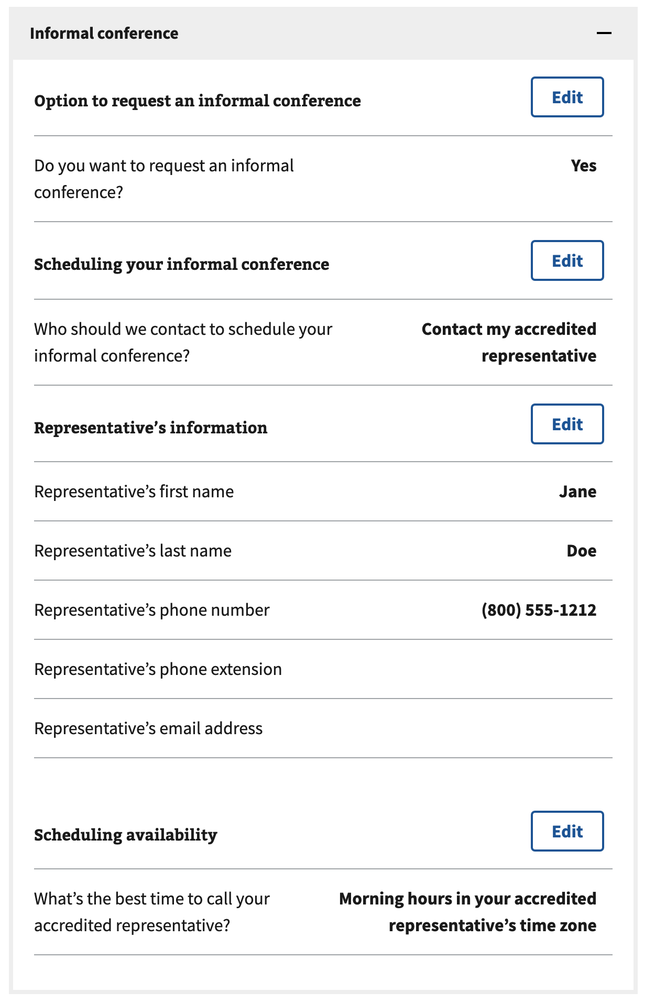

#### Option to request an informal conference – Edit

The user is able to select the edit button and edit information as needed. Field requirements are the ‘Option to request an informal conference’.

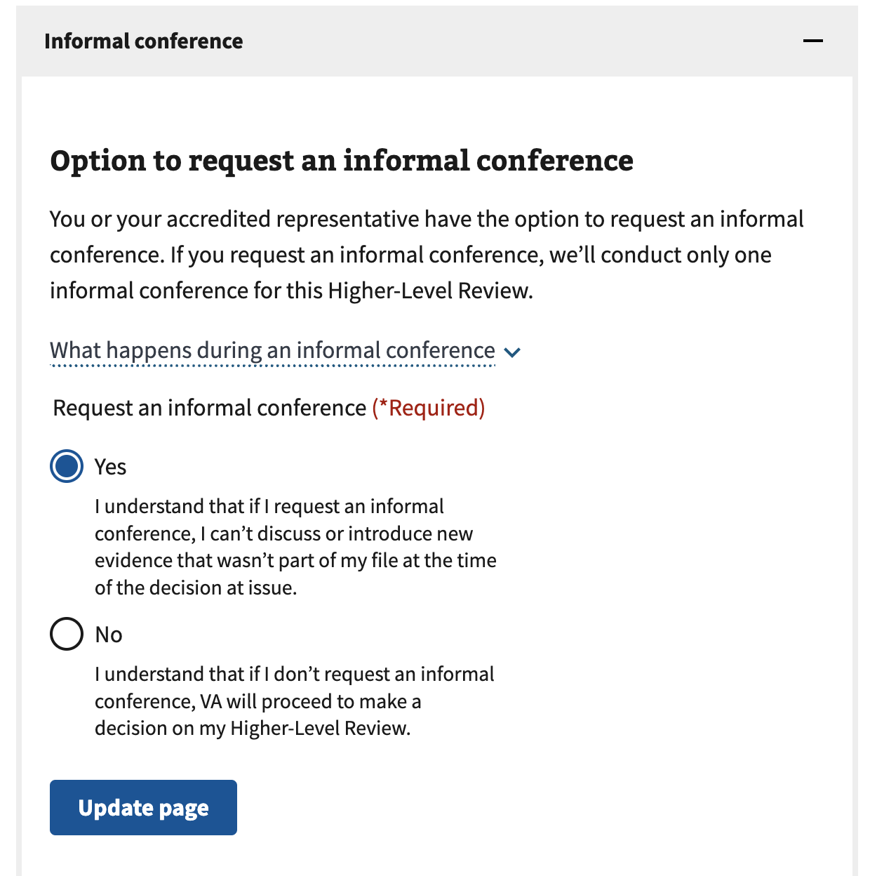

Once done, they can select “update page” to return to the previous view.

#### Scheduling your informal conference – Edit

The user is able to select the edit button and edit information as needed. Field requirements are the same as ‘Scheduling your informal conference’.

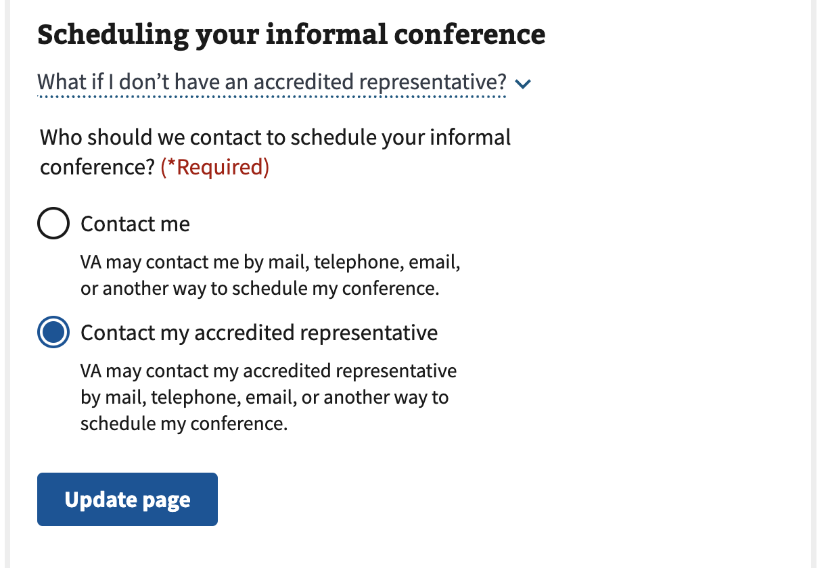

Once done, they can select “update page” to return to the previous view.

##### 

#### Best time for us to call you – Edit (if selecting “Contact Me”)

This view is only seen if the “Scheduling your informal conference” choice was set to “Contact me”.

The user is able to select the edit button and edit information as needed. Field requirements are the same as ‘Best time for us to call you’.

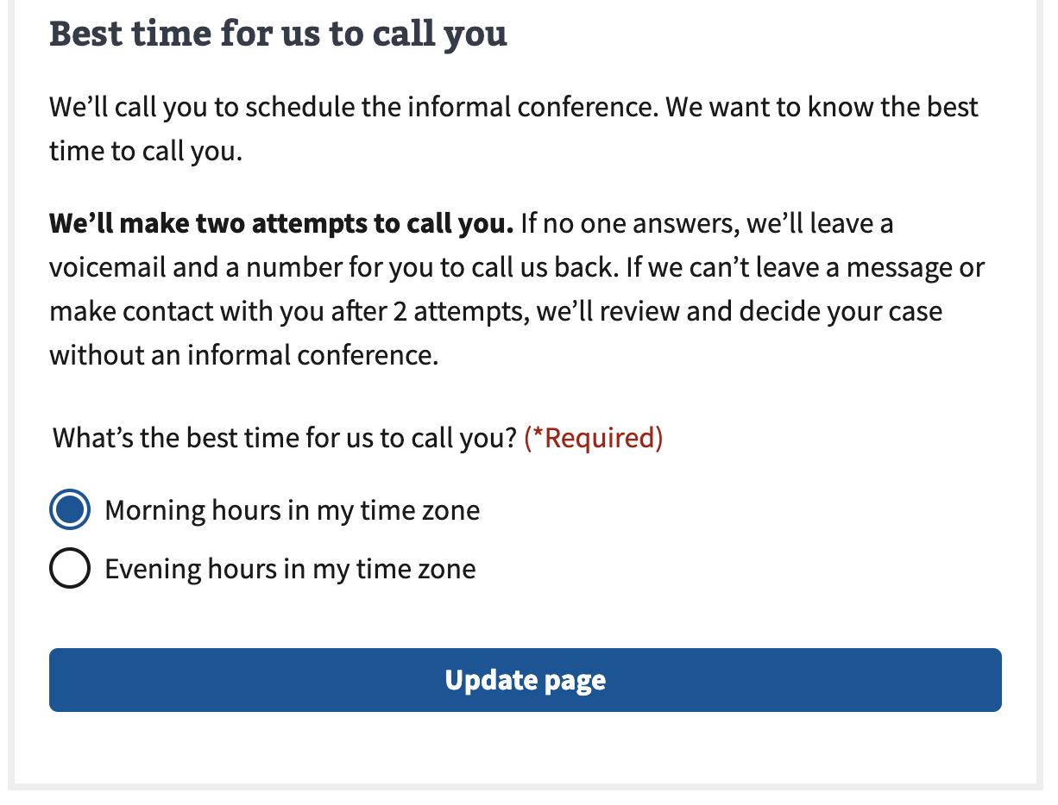

Once done, they can select “update page” to return to the previous view.

#### Your representative’s contact information - Edit (if selecting “Contact my accredited representative”)

This view is only seen if the “Scheduling your informal conference” choice was set to “Contact my accredited representative”.

The user is able to select the edit button and edit information as needed. Field requirements are the same as ‘Your representative’s contact information’.

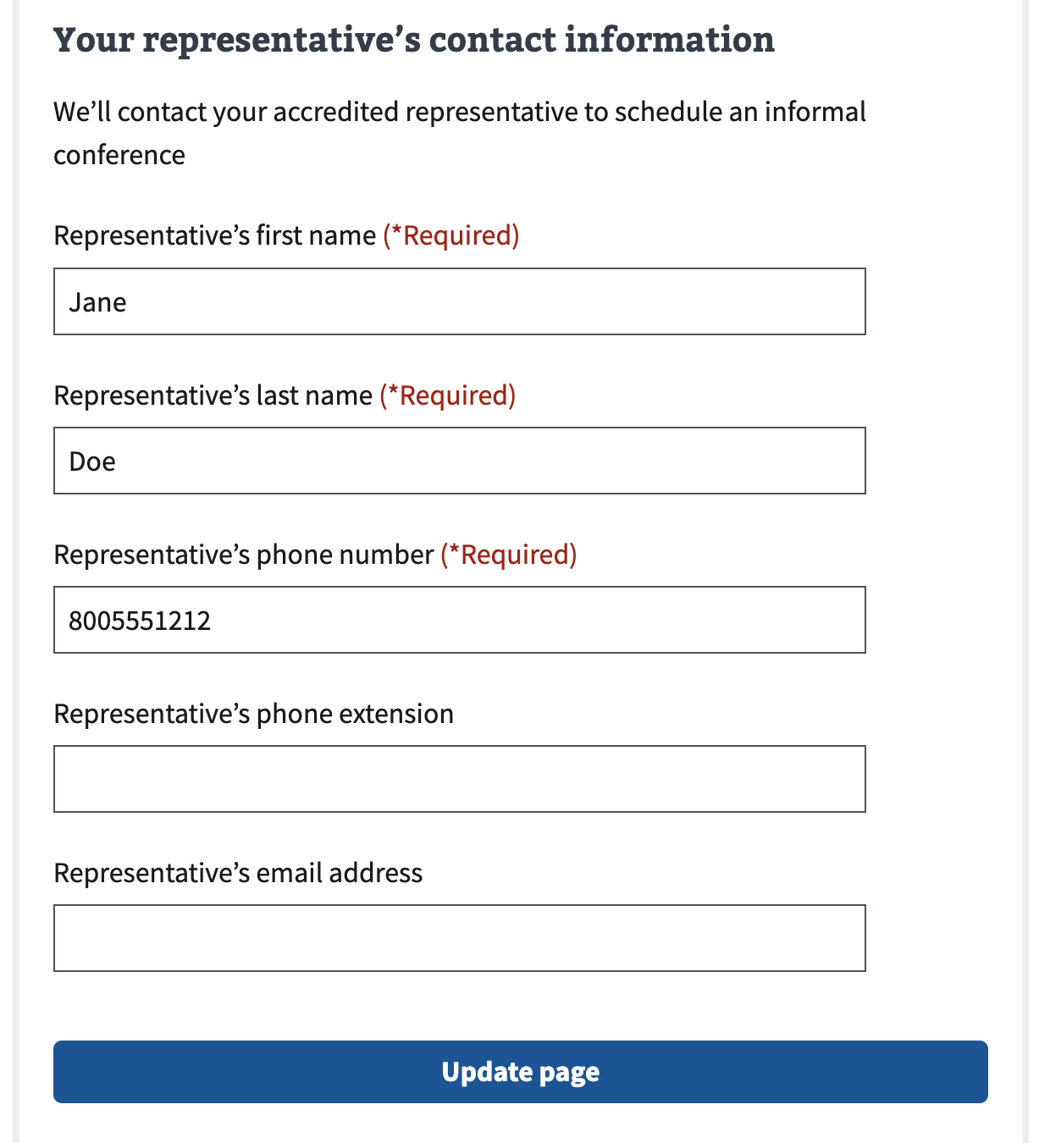

Once done, they can select “update page” to return to the previous view.

#### Best time for us to call your accredited representative - Edit (if selecting “Contact my accredited representative”)

This view is only seen if the “Scheduling your informal conference” choice was set to “Contact my accredited representative”.

The user is able to select the edit button and edit information as needed. Field requirements are the same as step 3, ‘Best time for us to call your accredited representative’.

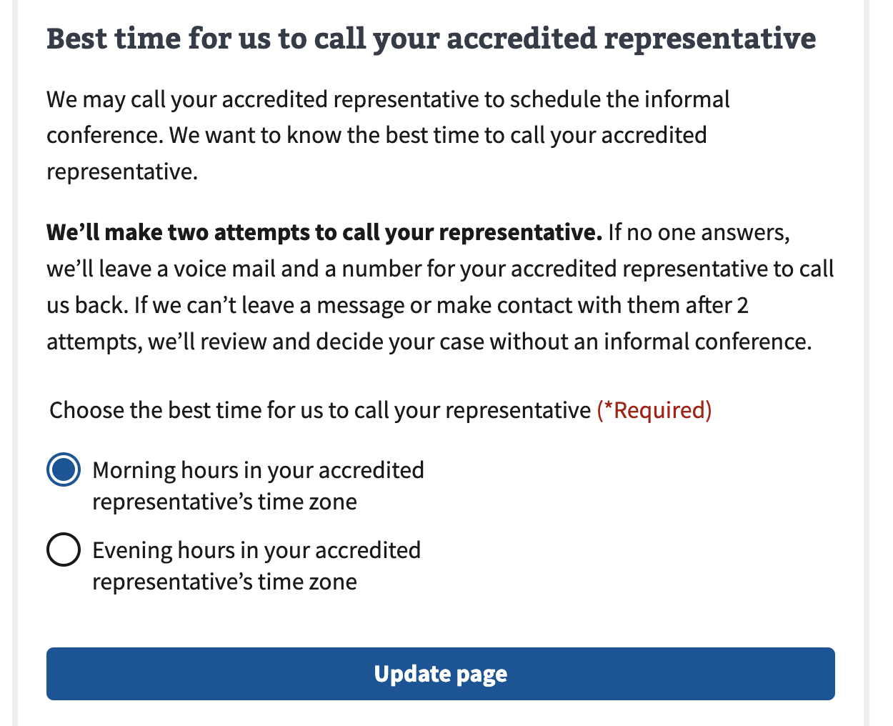

The user is able to select the edit button and edit information as needed. Field requirements are the same as step 3, ‘Your representative’s contact information’.

#### Privacy policy

This field is required to submit the application.

| Field | Required |
| --- | --- |
| I have read and accept the Privacy Policy | Yes |

#### Submit

When the user has satisfied all of the field requirements and is ready to submit the form, they can select the “Submit application” button at the bottom of the review page.

Which will take them to the submission confirmation page (seen on next page).

### Submission confirmation

After selecting “submit application” the user will be shown this page which contains a summary of the request, and links to more information about decision reviews.

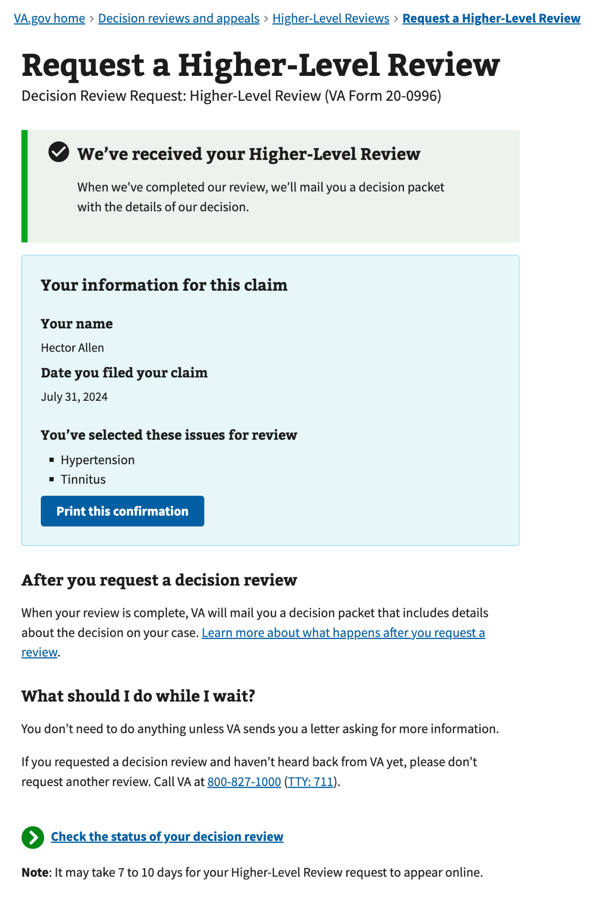

## 

## Email Error Notification

If the form fails at any point post-submission, we will send the Veteran an action needed email notifying that their form submission has failed, and that they should resubmit the form by mail to avoid further issues.

